Airflow:

Orchestrator allows you to author, manage, and monitor workflows at scale.

Benefits:

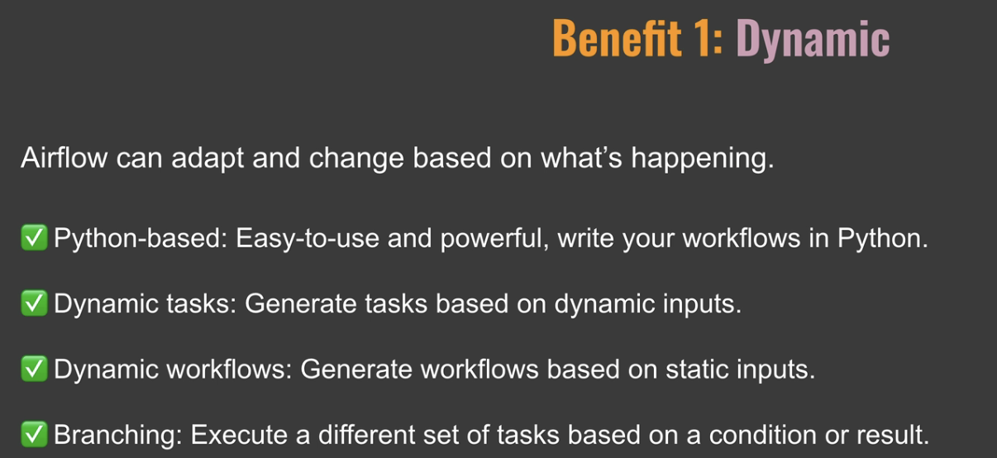

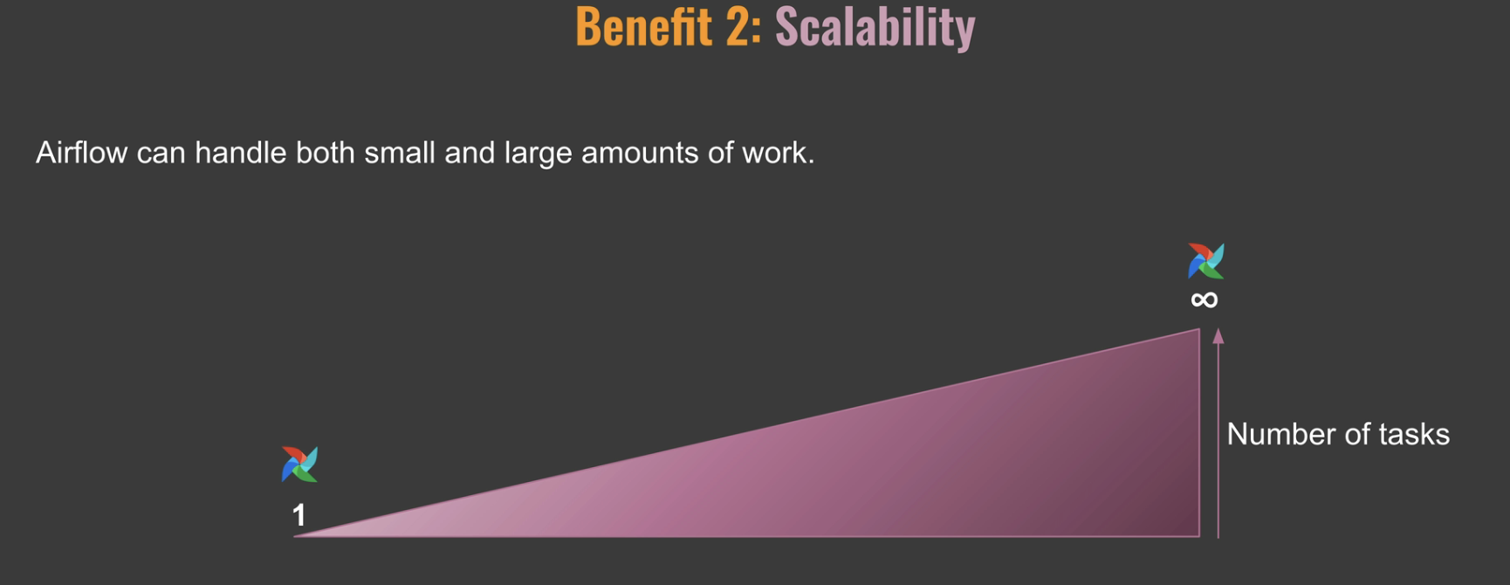

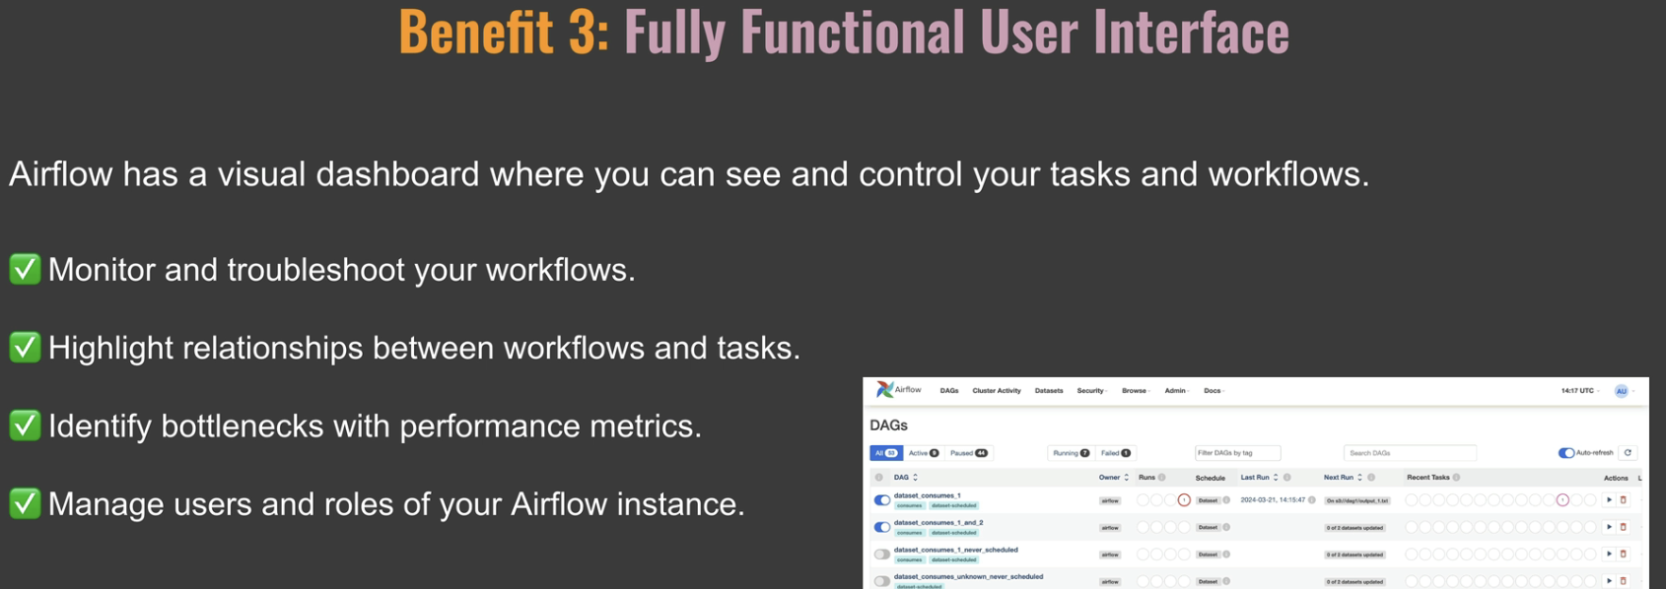

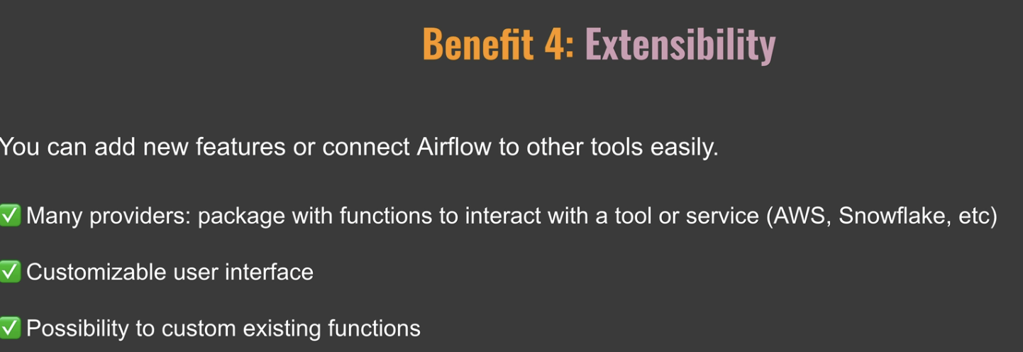

Components:

Webserver:

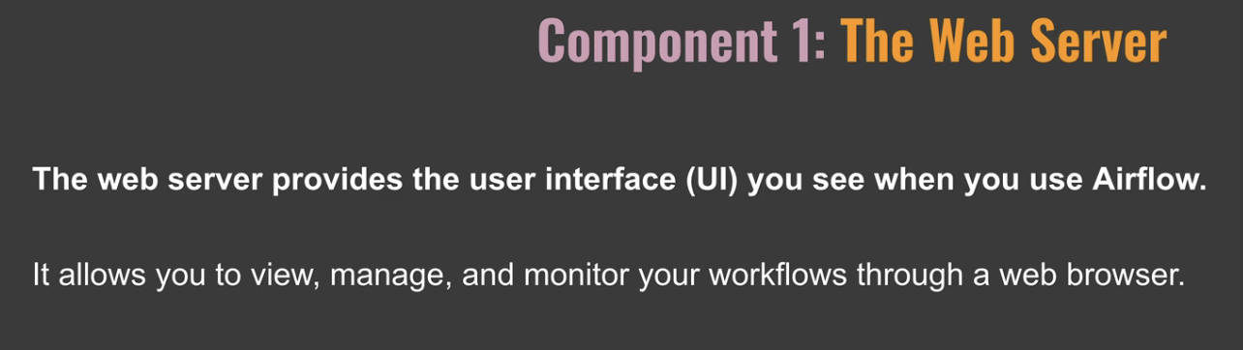

Scheduler

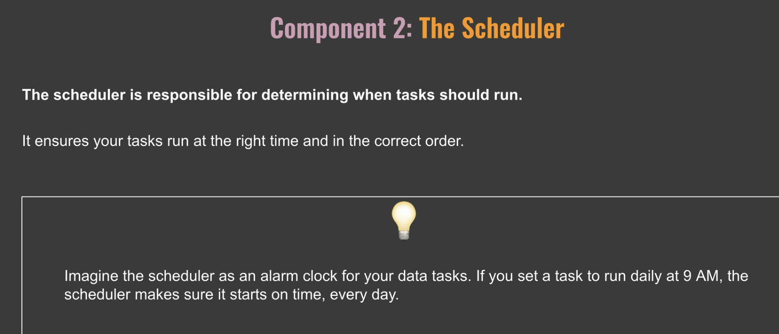

Meta database

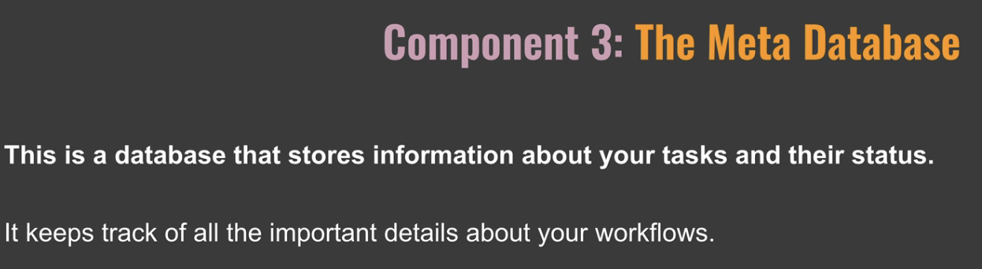

Trigger:

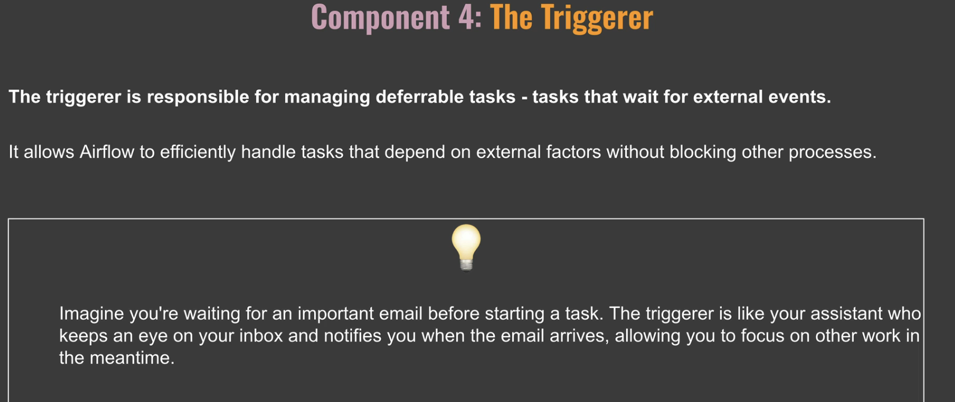

Executor:

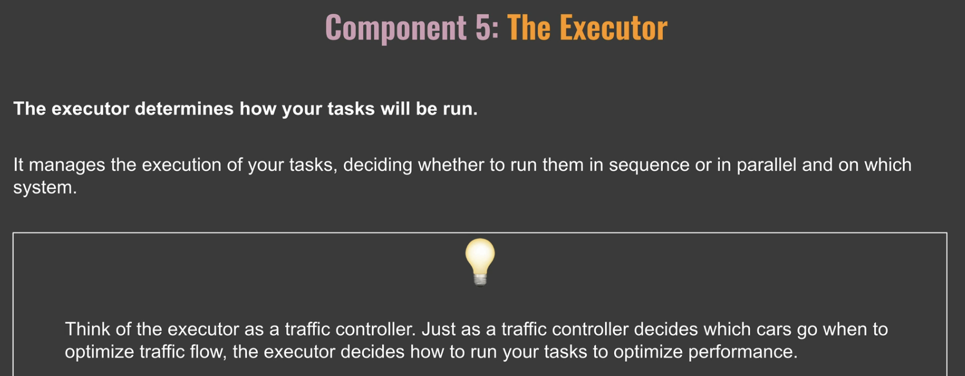

Queue:

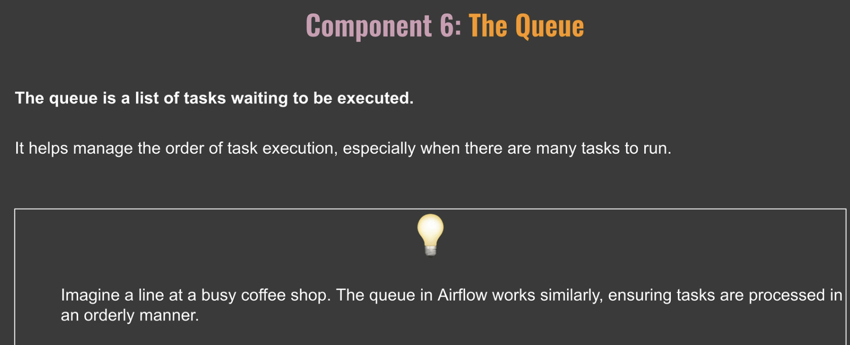

Workers:

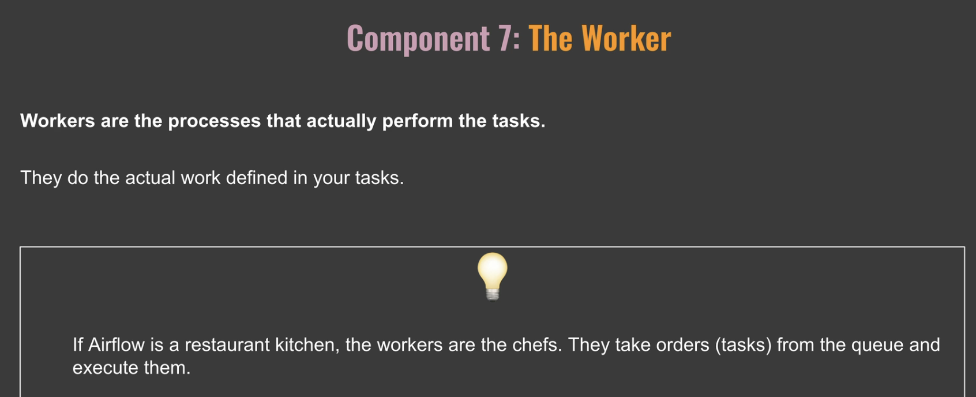

DAG:

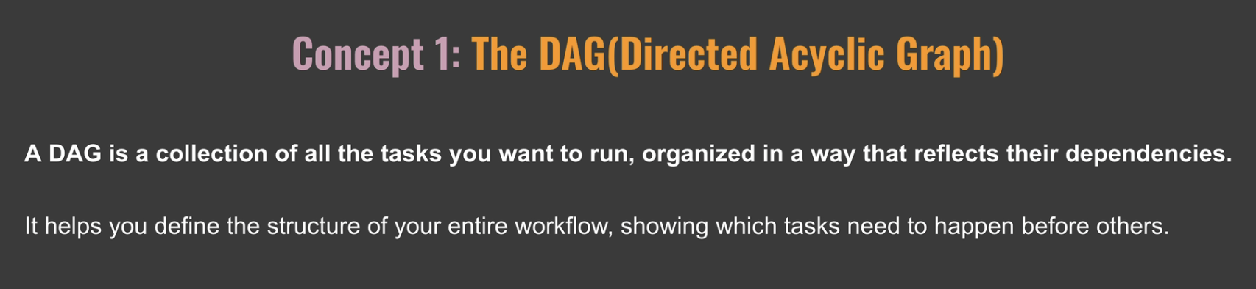

Operator:

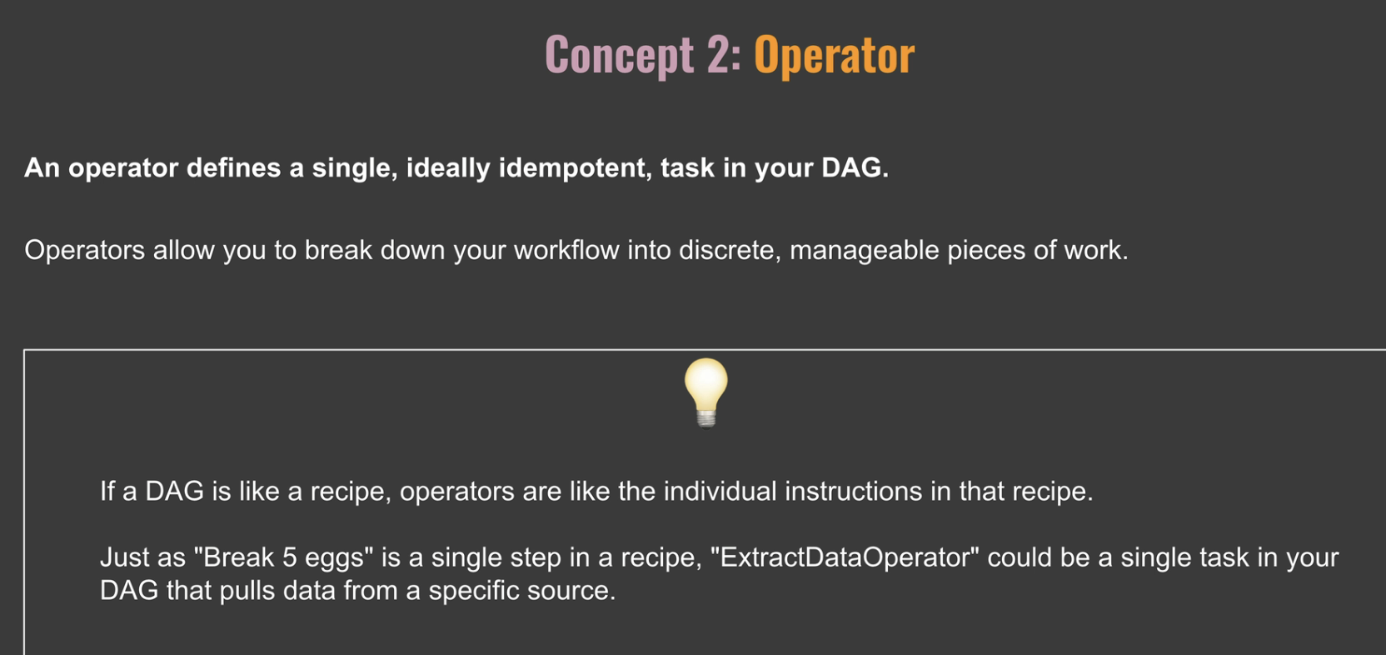

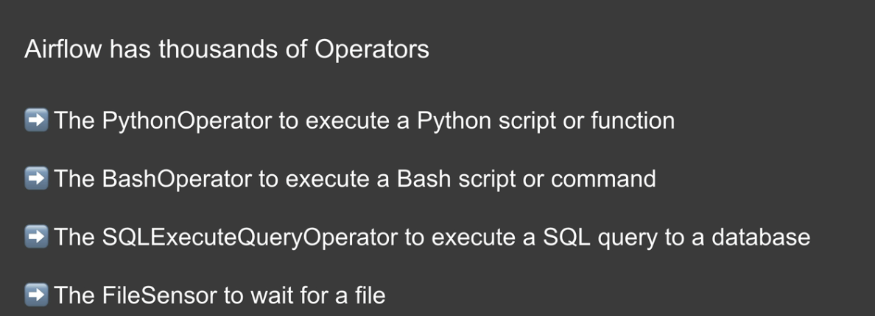

Task Instance:

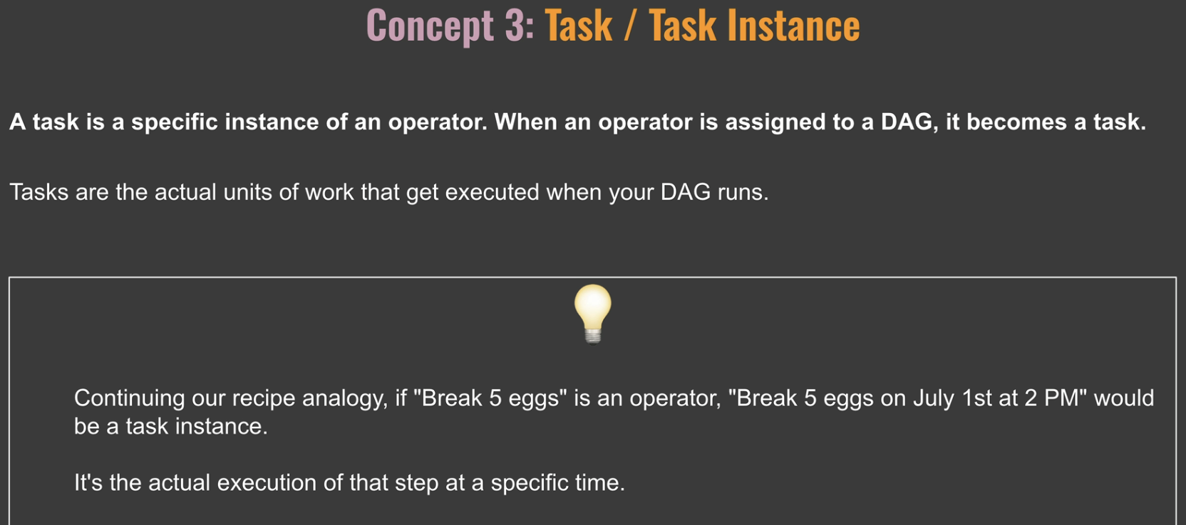

Workflow

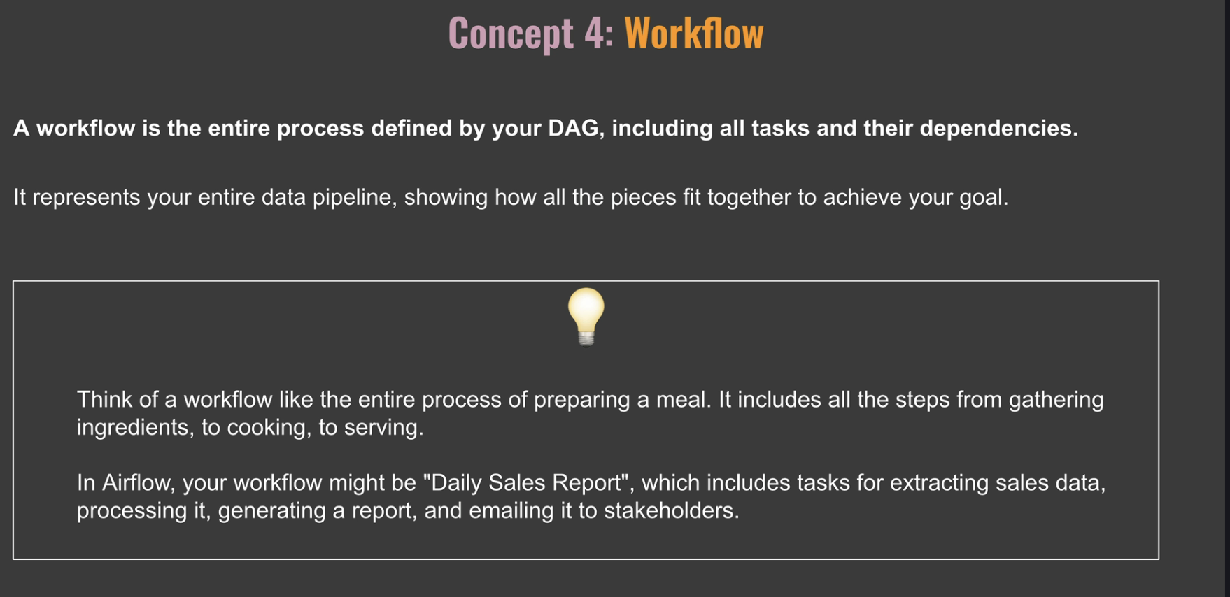

What Airflow is Not:

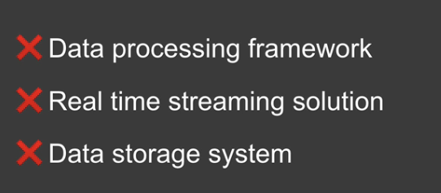

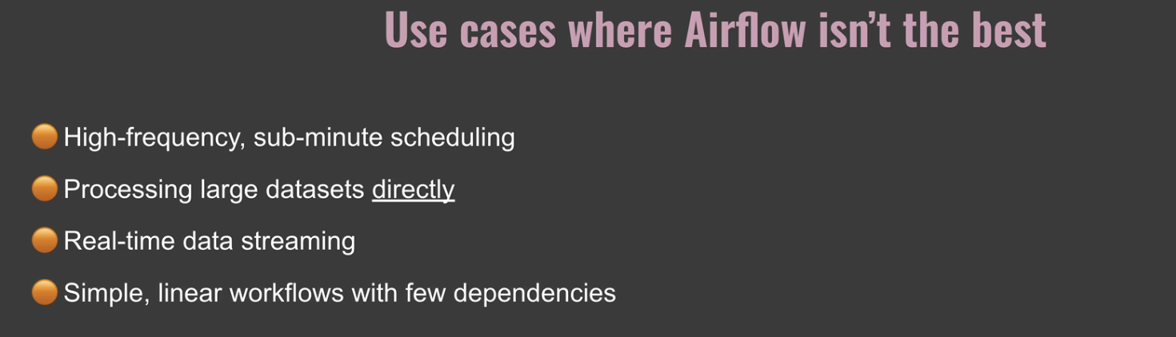

Airflow Architecture:

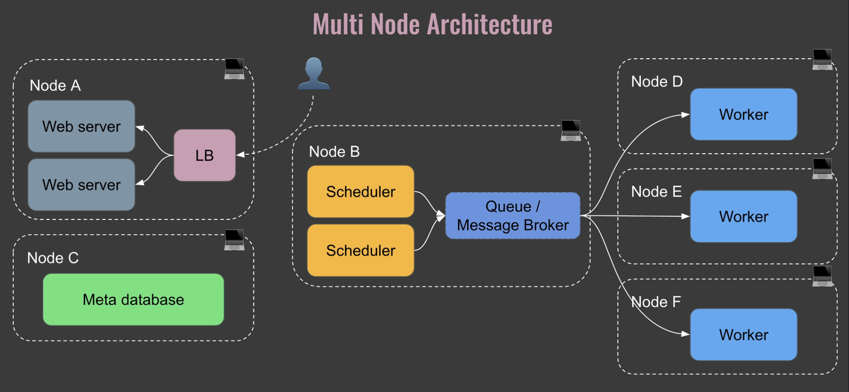

Multi-node refers to running airflow across multiple computers or servers rather than just one. This setup is used when you need to handle larger workloads or want more reliability. This is the typical setup you get when airflow runs in production to ensure performance, scalability, and reliability. Okay, let's discover how the components work together in a multi-node setup. So as you can see here we have multiple nodes multiple computers not A, B, C, D, E, and f. Let's begin with the web server. So just like in the single node setup this is your interface to airflow. However, in a multi node setup it might run on its own dedicated machine to handle more users. And you can have more than one web server as you can see here. In addition, you can add a new component which is the load balancer. And this new component sits in front of your web servers. It distributes incoming web traffic across the web server instances to improve responsiveness and reliability. So this is very useful if you have many users accessing the user interface of airflow. And also if one web server goes down, you still have the other one. So you always have access to the UI. Then you have the scheduler. And in a multi-node setup you might have multiple schedulers for reliability, so that if one scheduler goes down, you still have the other one that keeps scheduling the tasks. Also, as you can have multiple schedulers, you can increase the number of tasks that you can schedule at the same time. Next we have the workers. And unlike in a single node setup, workers are now separate processes running on different machines. You can see that you have one worker in node D, then one in node E and one in node F, and they still pick up and execute tasks that they pull from the queue. Speaking of the queue, it's a little bit different now because in a multi node setup the queue becomes a separate component, often using a message broker like Redis or RabbitMQ to distribute the tasks from the scheduler to the workers. A message broker is a software that manages the queue in a multi-node setup. It ensures tasks are reliably passed from the scheduler to the workers, so it's more complex than with the single node setup where the queue was part of the executor. And by the way, I don't show you the executor here, but regardless of the setup you use, the executor is always part of the scheduler. Finally, there is the meta database, and this is still the airflow's central memory. But it's now typically a more robust database like Postgres running on its own machine for better performance, like with the single node architecture. All the components are still communicating between each other through the meta database. I didn't put the arrows for keeping the clarity of the schema. Also, if you wonder why the web server is in node A, and then in node B, you have the scheduler or the metadatabase in node C. Honestly, it's up to you. You could definitely have the scheduler and the web server sitting in the same node, and have the Metadatabase sitting in a dedicated node. It depends on your infrastructure, your budget and what you are trying to achieve. So this is just an example. There are few benefits of using this setup. First, it is scalable. You can add more workers to handle larger workloads. Also, it is reliable if one machine fails or one component fails, others can take over its work. And also in terms of performance, it is much better because you can distribute work across machines so you can process more tasks at the same time. However, this setup is way more complex to manage and might be overkill for smaller workflows. This multi-node architecture is great for larger organizations with complex workflows, high reliability needs, or large volumes of tasks. It allows airflow to scale up to meet demanding workloads while providing better fault tolerance. That's it for this video. In the rest of the course, we will stick to the single node architecture.

How Airflow Works:

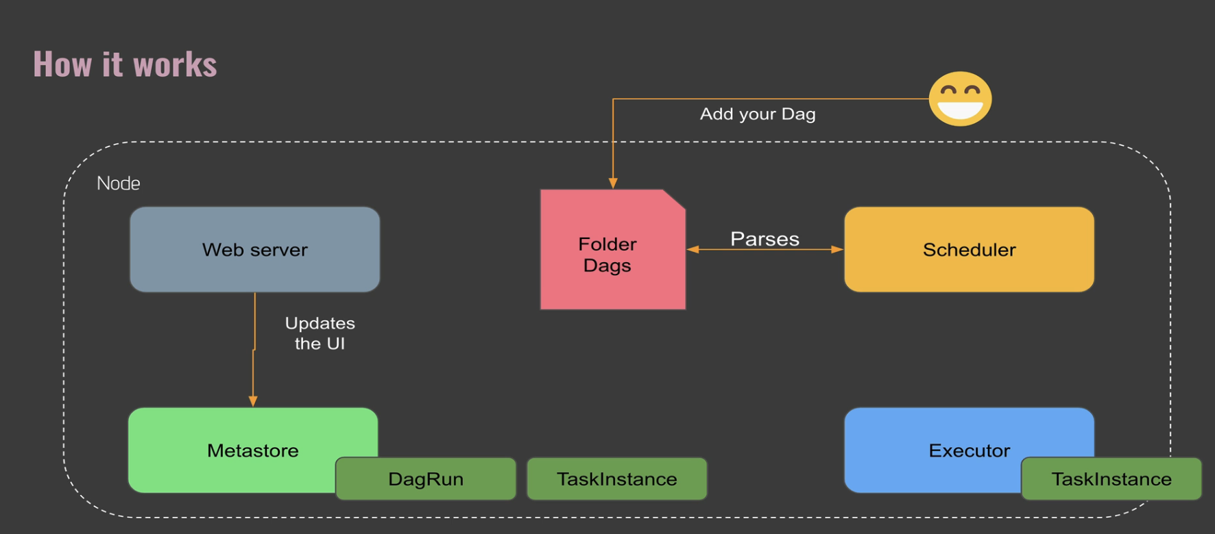

In this video, you will discover what happens when you run a Dag in airflow. Let's dive in. Let's imagine you have just created a new Dag called Daily Report. Dag. Here is what happens. You write your Dag file, let's call it Daily Report Magpie and place it in the DAGs folder. Then the scheduler regularly scans the DAGs folder. It finds your new daily report Dag file and reads it. The scheduler sees that your Dag is ready to run based on its schedule or dependencies. So the scheduler creates a diagram, which is an instance of your Dag at a given time, and it marks the Dag run as queued in the meta database. If a task is ready, the scheduler marks the dagrun as running in the meta database. It creates a task instance corresponding to the task. Remember that a task instance is an instance of a task at a given time, and it marks the task instance as scheduled in the meta database. Then the scheduler sends the task instance to the executor and its status is queued in the meta database. Remember that the executor does not execute tasks. It defines how and on which system to execute your tasks. So as we are using the single node architecture, the executor creates a process corresponding to a worker, and this worker takes the task instance from the queue to execute it. The worker marks the task instance as running in the meta database. Once the task is completed, the worker marks the task instance as success in the meta database. Obviously it can be another state like failed or up for retry. Finally, if there are no more tasks to execute for this specific Dag, the Dag run is completed with the status success. Again, it can also fail. While all of that is happening, you can track the state of your diagrams and task instances from the airflow user interface. This is a very high level overview of what happens when you run the Dag in airflow. There are many other states that a task can have, but here you have the basics that you need to remember.

**[Practice] Installing Apache Airflow**

Installing Apache Airflow

Hi there 👋

It's time to install Apache Airflow. As you are going to see, it's very simple.

**Prerequisites**

First, make sure you have installed Docker Desktop and Visual Studio. If not, take a look at these links:

* [Get Docker](https://docs.docker.com/get-docker/)
* [Get Visual Studio Code](https://code.visualstudio.com/download)

Docker needs privilege rights to work, make sure you have them.

**Follow the documentation first.**  
If you have trouble to install these tools, here are some videos to help you

* [Install Docker on Windows 10](https://www.youtube.com/watch?v=lIkxbE_We1I&ab_channel=JamesStormes)
* [Install Docker on Windows 10 with WSL 2](https://www.youtube.com/watch?v=h0Lwtcje-Jo&ab_channel=BeachcastsProgrammingVideos)
* [Install Docker on Windows 11](https://youtu.be/6k1CyA5zYgg?t=249)

**Install Apache Airflow with Docker**

1. Create a folder **materials**in your **Documents**
2. In this folder, download the following file: [docker compose file](https://airflow.apache.org/docs/apache-airflow/2.5.1/docker-compose.yaml)
3. If you right-click on the file and save it, you will end up with docker-compose.yaml.txt. Remove the .txt and keep docker-compose.yaml
4. Open your terminal or CMD and go into **Documents/materials**
5. Open Visual Studio Code by typing the command: code .
6. You should have something like this

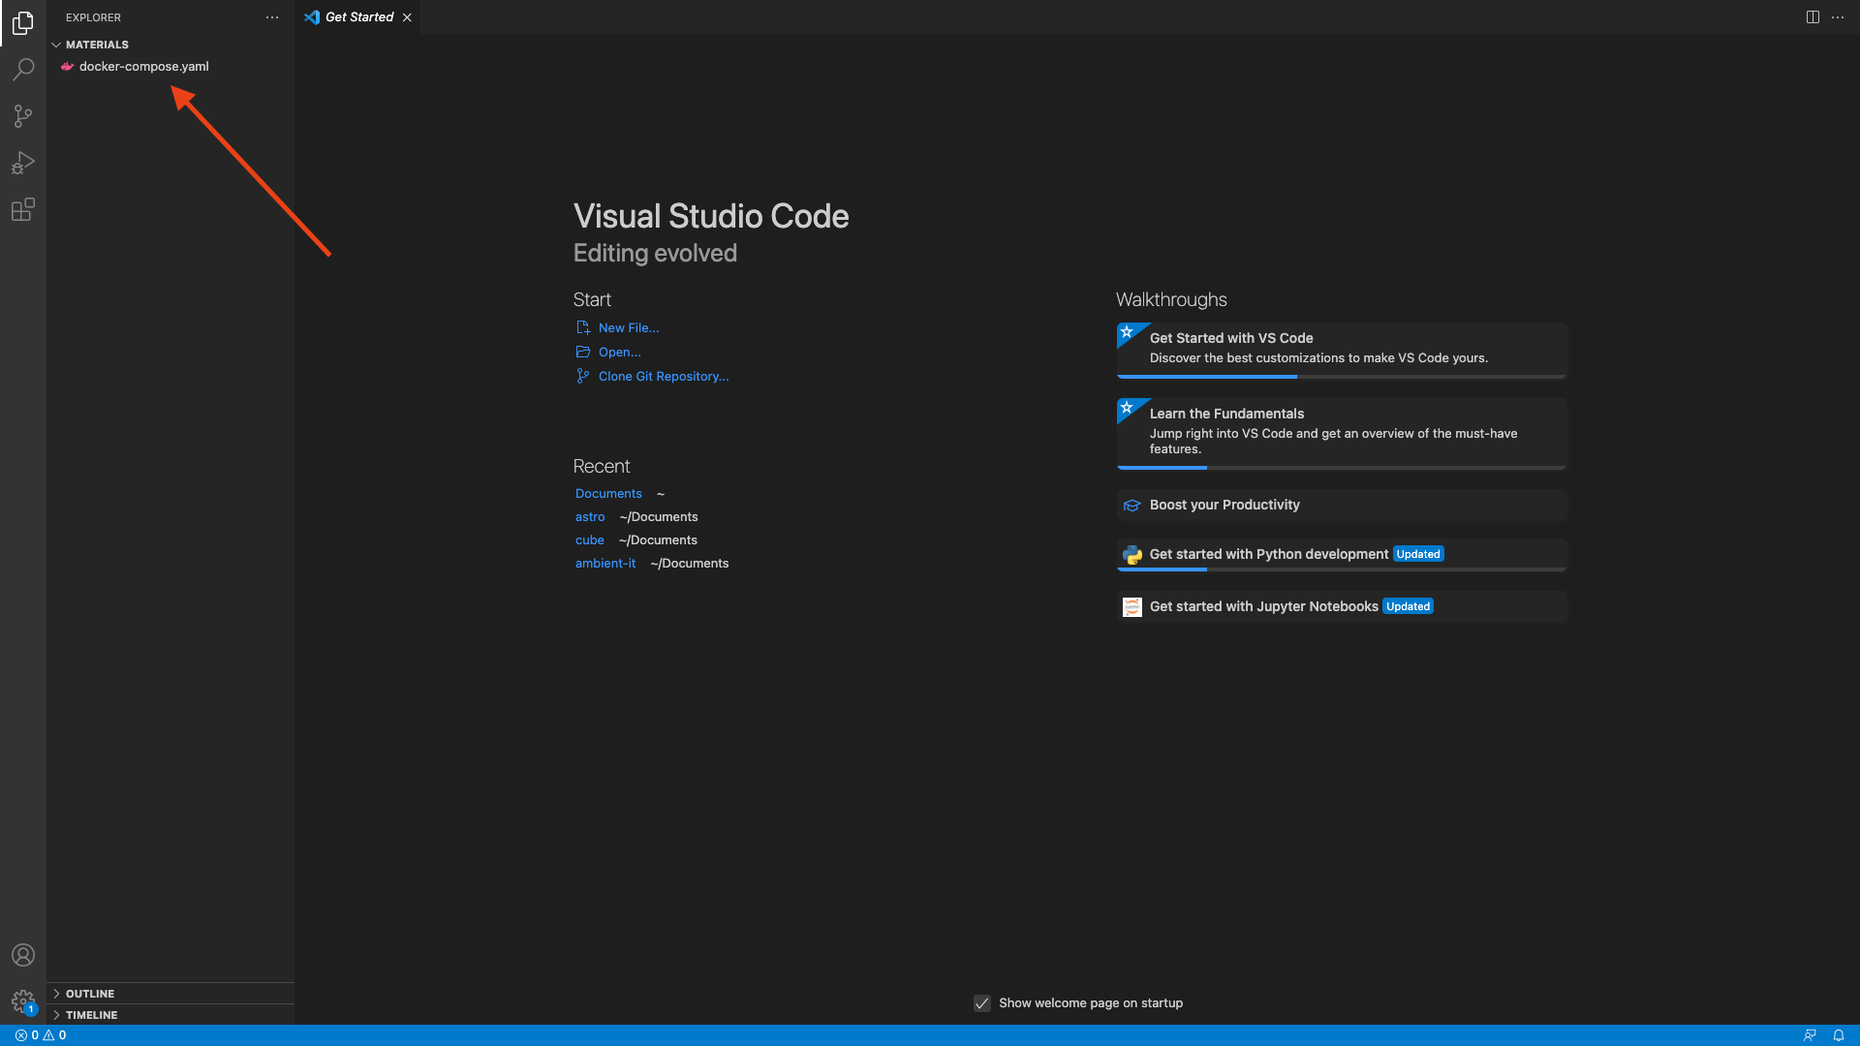

1. Right click below docker-compose.yml and create a new file .env (don't forget the dot before env)
2. In this file add the following lines
   1. AIRFLOW_IMAGE_NAME=apache/airflow:2.4.2
   2. AIRFLOW_UID=50000

and save the file

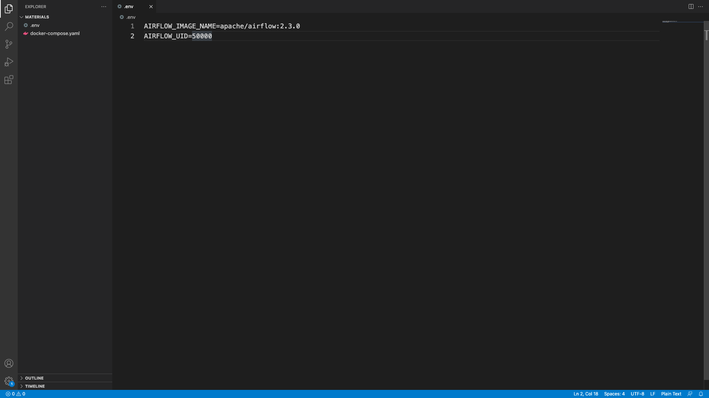

1. Go at the top bar of Visual Studio Code -> Terminal -> New Terminal

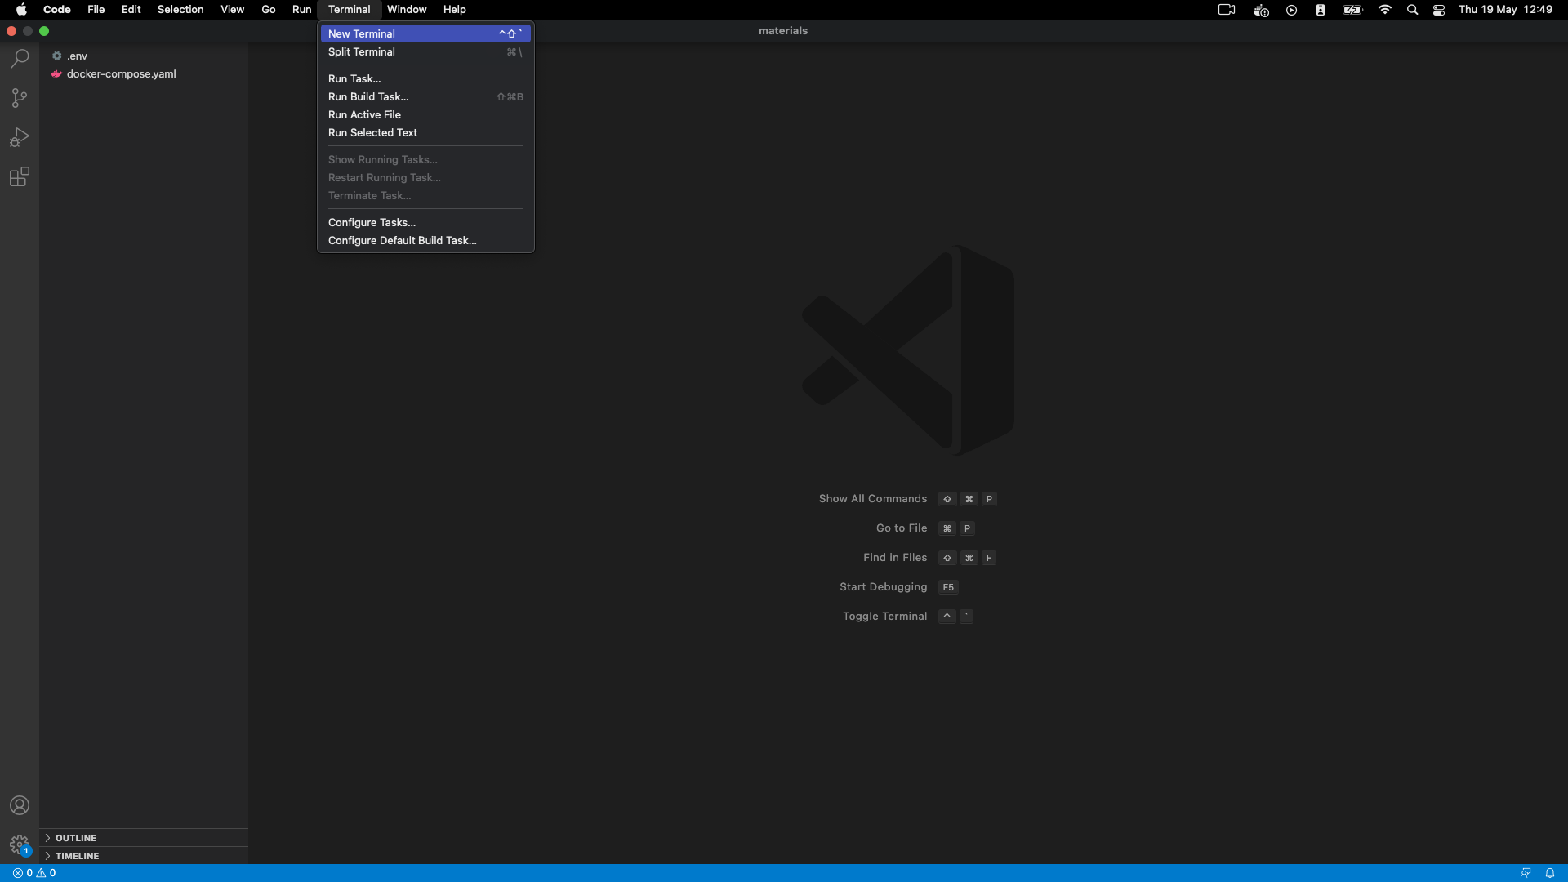

1. In your new terminal at the bottom of Visual Studio Code, type the command docker-compose up -d and hit ENTER

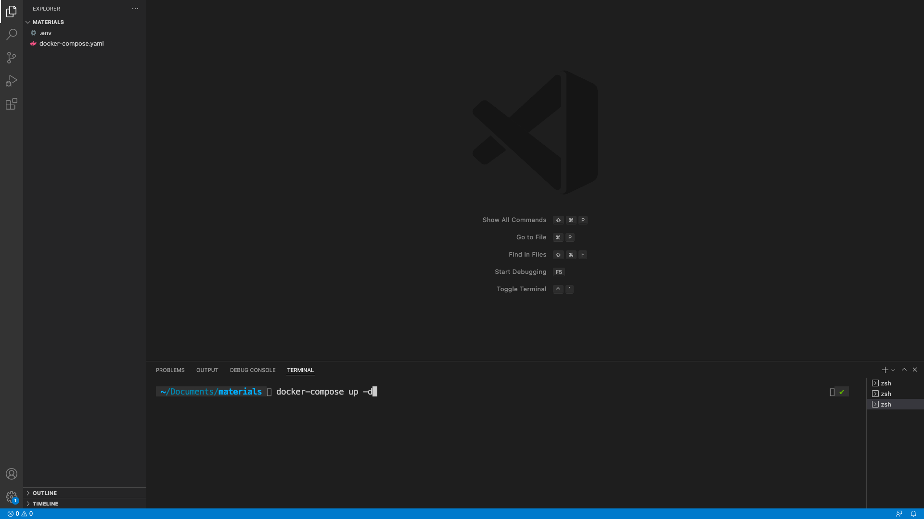

1. You will see many lines scrolled, wait until it's done. Docker is downloading Airflow to run it. It can take up to 5 mins depending on your connection. If Docker raises an error saying it can't download the docker image, ensure you are not behind a proxy/vpn or corporate network. You may need to use your personal connection to make it work. At the end, you should end up with something like this:

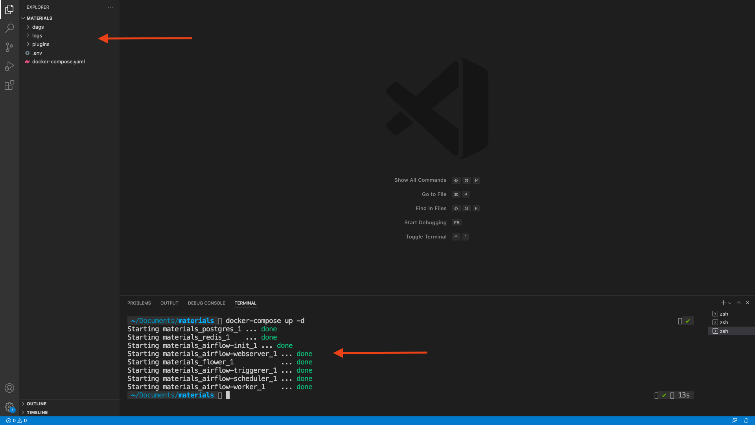

Well done, you've just installed Apache Airflow with Docker! 🎉

Open your web browser and go to localhost:8080

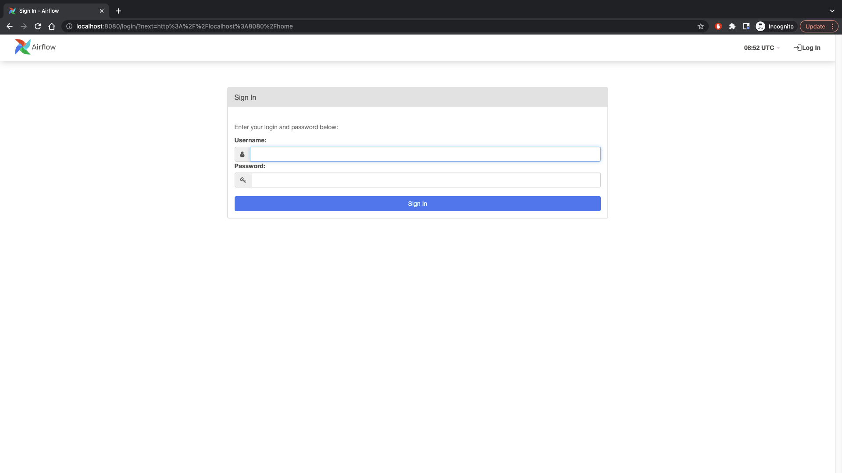

Troubleshoots

-> If you don't see this page, make sure you have nothing already running on the port 8080

Also, go back to your terminal on Visual Studio Code and check your application with docker-compose ps

All of your "containers" should be healthy as follow:

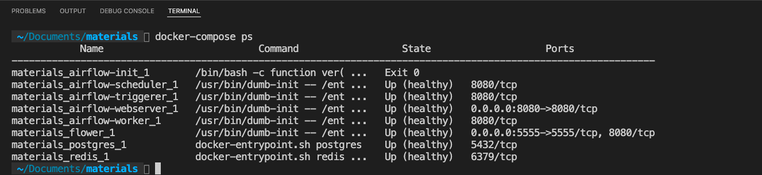

If a container is not healthy. You can check the logs with docker logs materials_name_of_the_container

Try to spot the error; once you fix it, restart Airflow with docker-compose down then docker-compose up -d

and wait until your container states move from starting to healthy.

-> If you see this error



remove your volumes with docker volume prune and run docker-compose up -d again

-> If you see that airflow-init docker container has exited, that's normal :)

If you still have trouble, reach me on the Q/A with your error.

What is DAG:

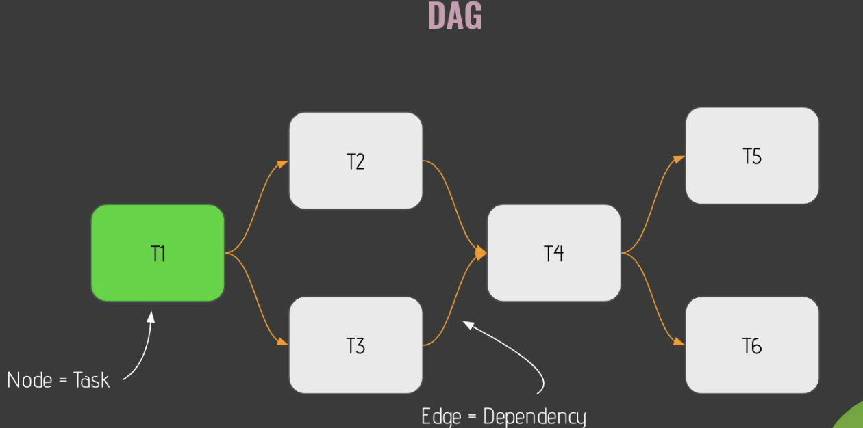

Catch Up:

The last parameter that we want to add here is the catchup parameter. I strongly advise you to set it to false. Why? Because by default the catch parameter is set to true. And it means that if between now and the start date your DAG hasn't been triggered, then as soon as you start scheduling your data pipeline from the F2 UI, you are going to catch up. You are going to run all the non triggered DAG runs between this period of time between now and the start date or the last time that your DAG has been triggered. So in my opinion, it's always good to set the capture parameter to force so you can control exactly what that wants. You want to run and you are not going to end up with a ton of diagrams running at the same time.

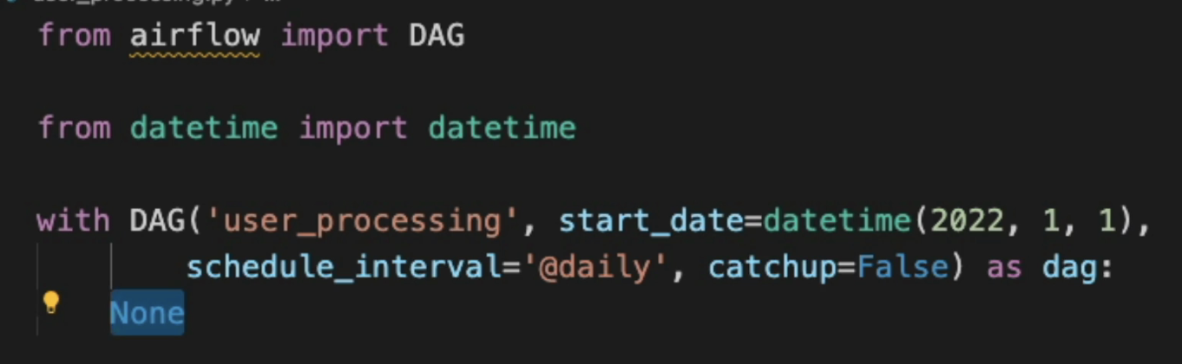

Operator:

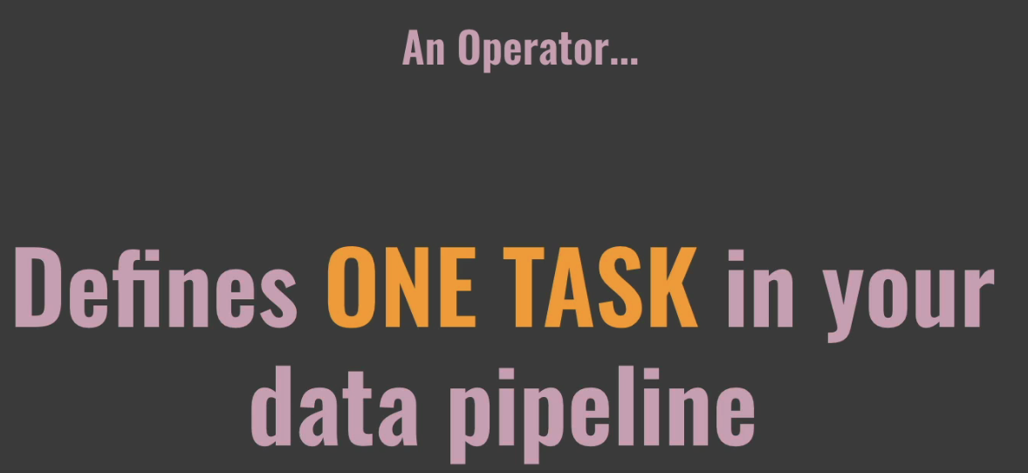

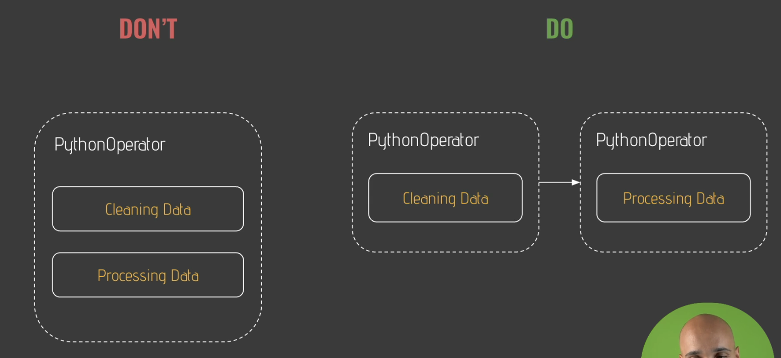

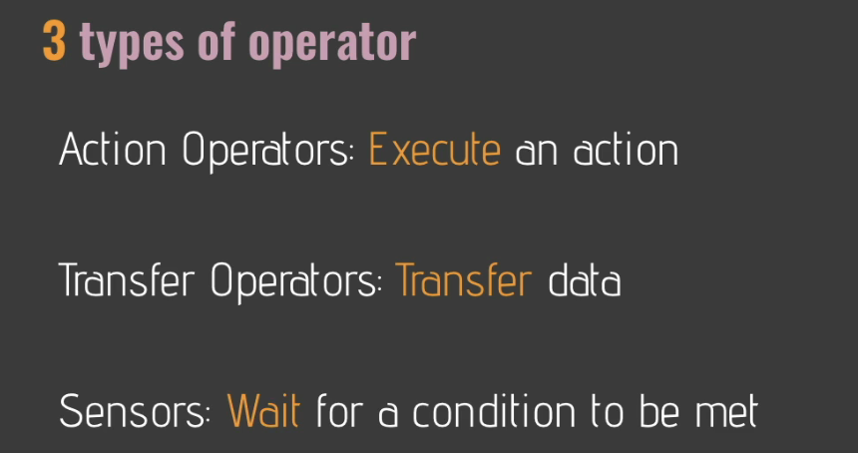

Sample DAG with postgres connection

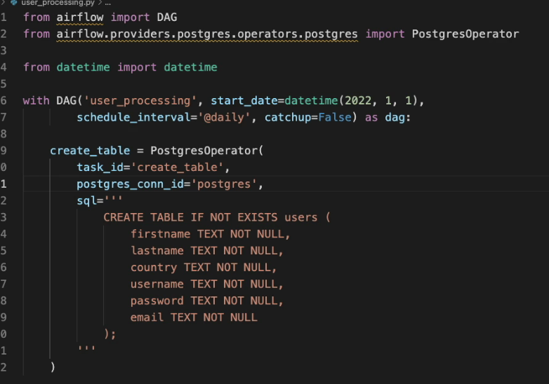

To Test DAG:

Go to webserver pod



Sensor:

Let me give you a quick update about the sensors, because they are very important. So let's imagine that you are waiting for your bus to come and you are sitting on that bench for a while and hopefully at some point you are able to see your bus coming. Whoa, finally. So you stand up and you walk in into the bus. Well, guess what? A sensor in the context of airflow. This is you waiting for your bus. But instead of waiting for a bus, a sensor will wait for whatever you want. In F2, for example, files to land at a specific location or entries in a circle table. It's up to you. And there are many sensors that exist in airflow. What I would like you to remember is that there are two parameters that you need to know both interval, which is defines to 60 seconds by default. So every 60 seconds the sensor checks if the condition is true or not before executing the next task and timeout, which is defined to seven days by default. So I strongly advise you to always define the timeout for your sensor and obviously it tells in seconds when your sensor times out and fails. Now on the UI, if you trigger your DAG by turning on the toggle right there and wait for your tasks to be completed, if you click on Ease API available and check the logs, you can see booking API slash with this URL and that means exactly what it means. It means that every 60 seconds it box it verifies if that URL is valid or not. And that's the goal of sensors. They wait for something to happen before executing the next task.

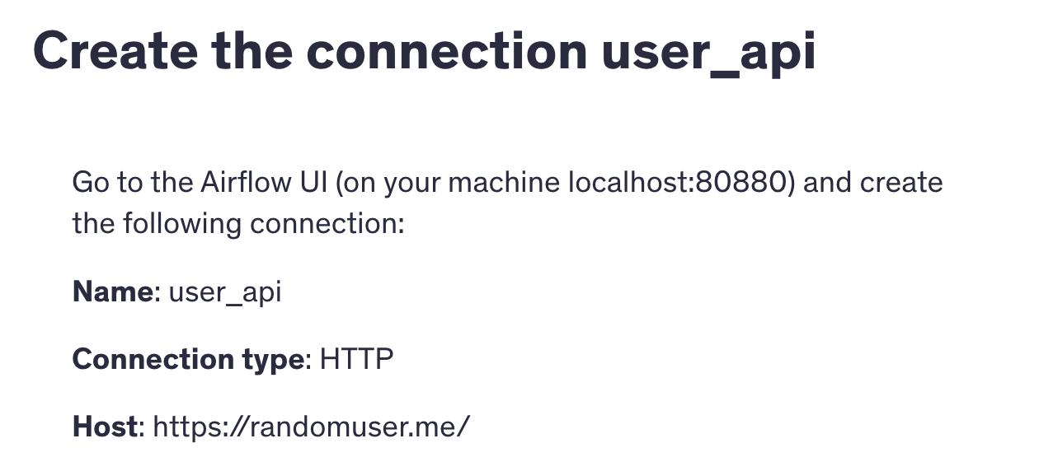

Hooks:

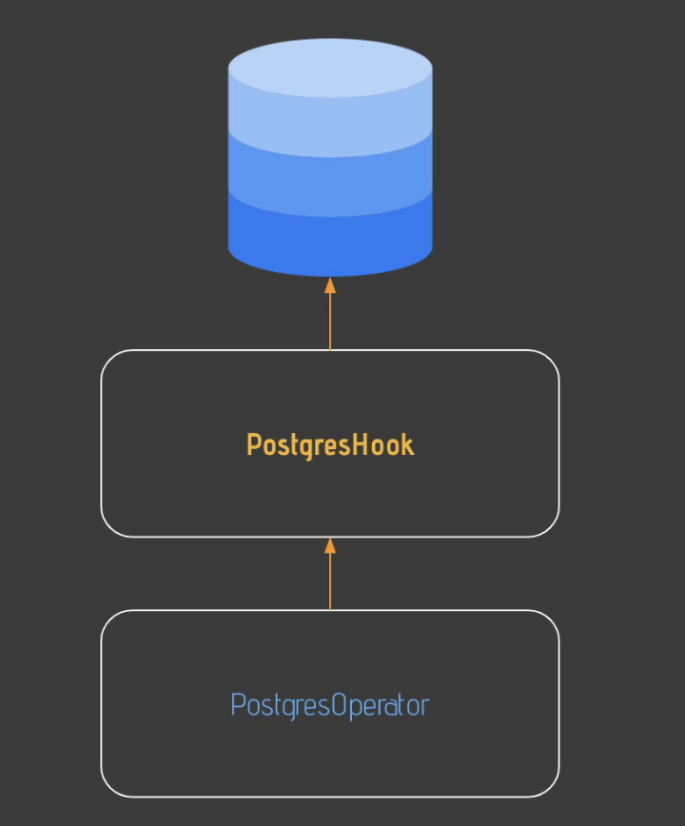

With a airflow, you can interact with many tools and to make sure that it is easy for you to interact with the tool. There is the concept of Hook. Let me tell you what it is. Let's imagine that you have the operator and you want to execute a SQL request to a PostgreSQL database. And guess what? With the postgres operator, you can execute a SQL request, but behind the scene a postgres hook is used and the goal of the post was hook is to abstract all the complexity of interacting with a Postgres database. So keep in mind, whenever you interact with an external tool or an external service, you have a hook behind the scene that abstracts the complexity of interacting with that tool or service. You have the attributes who, you have the hook, you have the MySQL hook and the list goes on. I strongly advise you to always take a look at the hook as you may have access to some methods that you don't have access to from the operator. So that is a hook. A hook allows you to easily interact with an external tool or an external service.

Create Dependency Between Tasks:



Dag Scheduling:

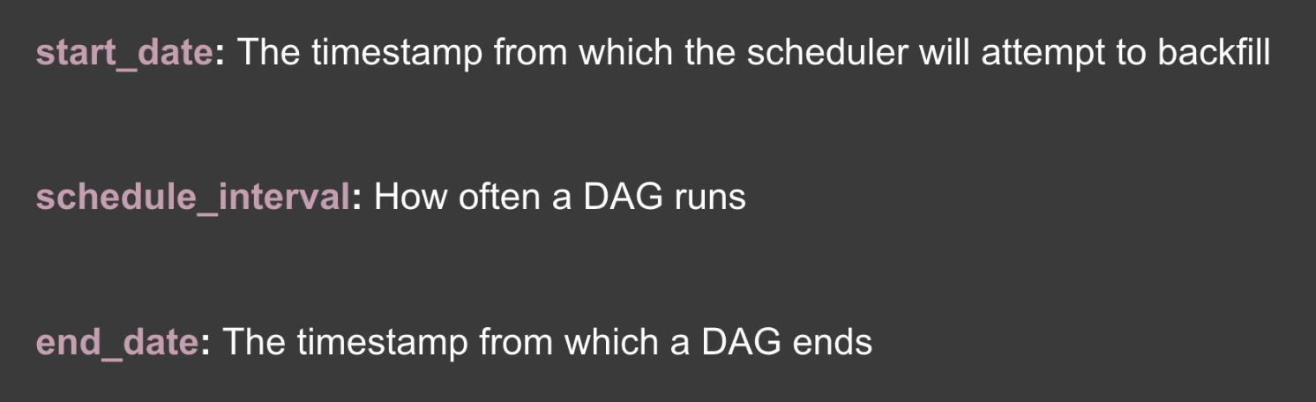

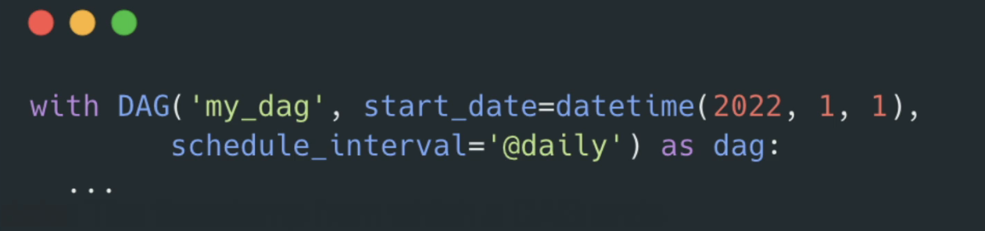

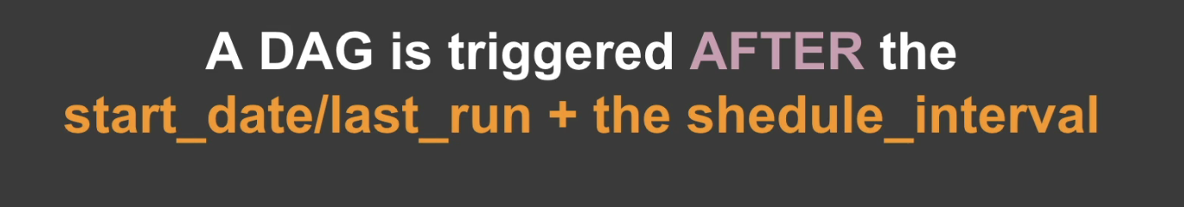

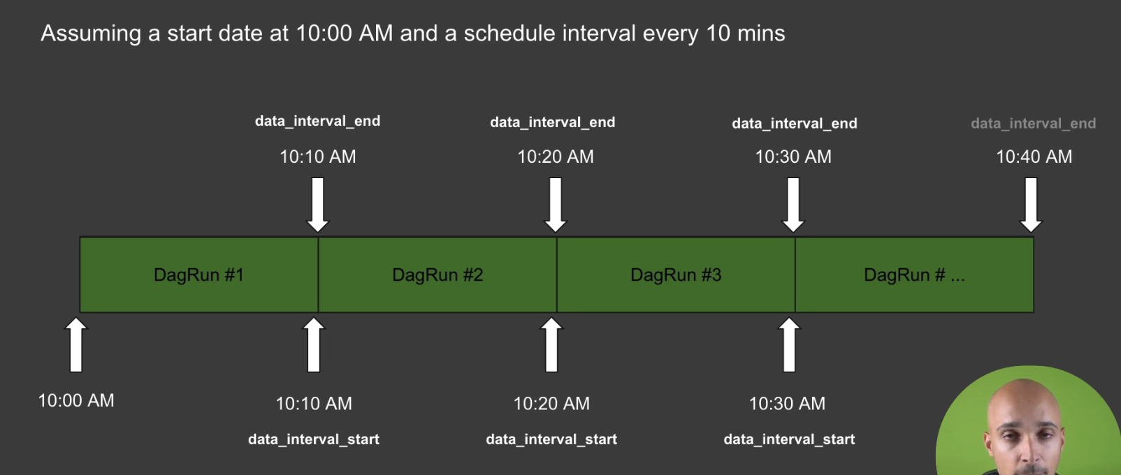

Let me show you how your dogs are scheduling airflow. And there are a couple of parameters that you need to know. The first one is the start date. The start date defines the date at which your dog starts being scheduled, for example, the 1st of January 2022. Next, you have the skill interval that defines the frequency at which your dog is triggered every 10 minutes, every 5 minutes, once in a day, and so on. Then, last but not least, you have the end date that defines the date at which you want to stop your dog. You don't have to define it, but you can. Now, at the dog level, you need to define the start date. You have to do it with a daytime object as shown right there, and you need to define the skill interval with the current expression or string object. If you don't know how to define your current expressions, take a look at the website Contact Guru that will help you a lot. And if you are wondering what is a daily behind the scene, that means the dog is triggered every day at midnight after it brings you some preset expressions like a daily, at hourly, at monthly, at weekly, and so on. Take a look at the full documentation for that. Now, when you trigger that, you obtain a diagram and a diagram covers a specific data interval which always has a data interval start, for example, here the 1st of January 2022, and the data interval will end here the 2nd of January 2022. Keep in mind that prior to the version 2.2 of air flow, the data interval start or the logical date is equal to the execution date above or equal to the 2.2 version. You will always see date interval, start and logical date. So keep in mind that grant covers a specific data interval and it has a data interval start and a data interval. And that being said, when your diet is actually triggered, well, keep in mind that that is triggered after the start date or the last time that your DAG was triggered, plus the serial interval. So let me show you this. You have a DAG with the start date, the 1st of January 2022 at 10 a.m. That is triggered every 10 minutes. At first, nothing happens yet at 10 a.m., nothing happens everywhere. It's 10 minutes. And then it is at ten and 10 a.m. that the first diagram is effectively triggered once it is completed. That diagram has a data interval start at 10 a.m. and the data interval end at ten and 10 a.m. for the second run again at ten and 10 a.m. for waits 10 minutes and it is at 10:20 a.m. that the second one is effectively triggered. And for that diagram, the data interval start is ten and 10 a.m. and the data interval end is 10:20 a.m.. Something for the cell diagram. It waits 10 minutes. The data interval start for the self. That run is 10:20 a.m. and the data interval end is 10:30 a.m.. So that's what you have to remember. Your DAG is effectively triggered after the start date or the last time your dag was triggered, plus the serial interval. That's what you can see here. And you always have the date interval start and the data interval and for every.

Backfillling:

Now the filling mechanism allows you to run historical that for example, you want to run your DAG prior to the start date from the 1st of January 2022 to the set of January 2022. You can do that. There is a command for this which is airflow dags backfill and you will end up with the following difference. So the backfilling mechanism allows you to run historical diagrams. Now you can modify the behavior of the catchup mechanism by set it to false at the DAG level, and in this case only the latest non triggered DAG run will be executed. Again, this mechanism is truly powerful because it allows you to rerun past non triggered DAG runs automatically.

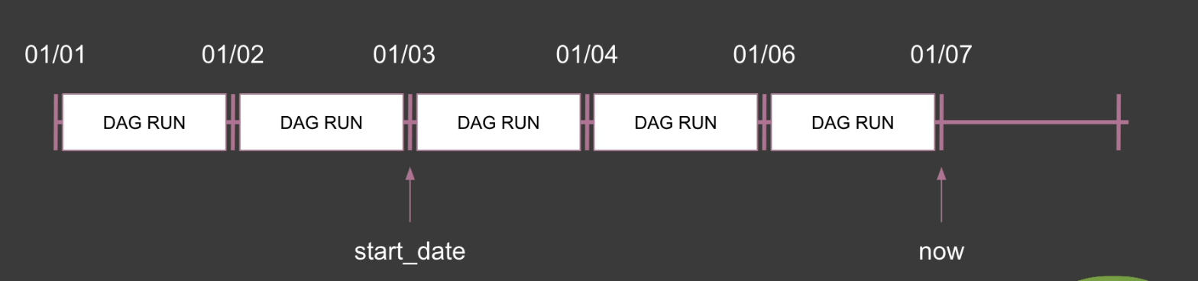

Catchup:

You do, I would like to show you one of the most important mechanism in airflow. So let's say that you have the following data pipeline that it is triggered every day at midnight. And the start date for this data pipeline is the 3rd of January 2022 and the date of now is the 7th of January 2022. If you run your diag for the first time, the scheduler automatically runs the non triggered difference between now and the start date. So you end up with the following that runs running. This is the catch up mechanism. The catch up mechanism allows you to automatically run non trigger that runs between the last time your DAG was triggered and the date of now. So for example, if you pause your dick during two days and then you input your dag, you will end up with some DAG runs corresponding to the non triggered DAG runs for this period of time. Now the filling mechanism allows you to run historical that for example, you want to run your DAG prior

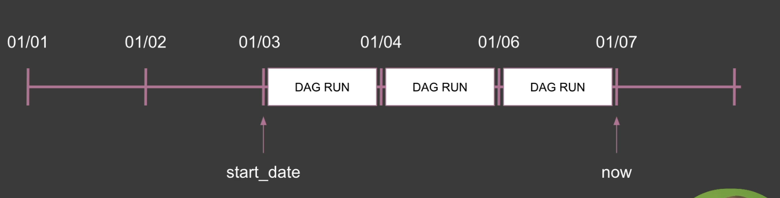

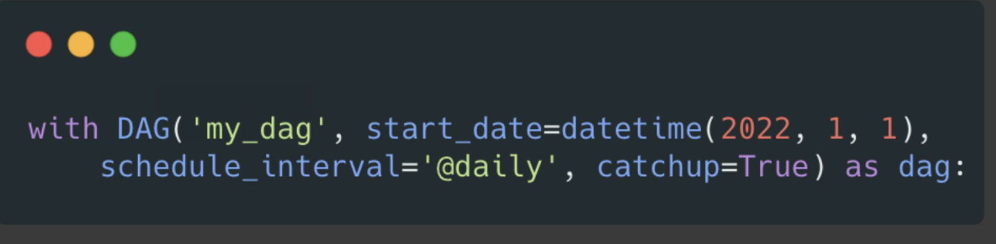

Complete Code:

**Wrap up!**

Well done! You've successfully created your first data pipeline with Airflow 😎

Now you are able to:

* Define a Data Pipeline
* Execute a SQL request with the PostgresOperator
* Execute a Python function with the PythonOperator
* Execute an HTTP request against an API
* Wait for something to happen with Sensors
* Use Hooks to access secret methods
* Exchange data between tasks

Here is the final code 👇

from airflow import DAG  
from airflow.providers.postgres.operators.postgres import PostgresOperator  
from airflow.providers.http.sensors.http import HttpSensor  
from airflow.providers.http.operators.http import SimpleHttpOperator  
from airflow.operators.python import PythonOperator  
from airflow.providers.postgres.hooks.postgres import PostgresHook  
  
import json  
from pandas import json_normalize  
from datetime import datetime  
  
  
def _process_user(ti):  
 user = ti.xcom_pull(task_ids="extract_user")  
 user = user['results'][**0**]  
 processed_user = json_normalize({  
 'firstname': user['name']['first']**,** 'lastname': user['name']['last']**,** 'country': user['location']['country']**,** 'username': user['login']['username']**,** 'password': user['login']['password']**,** 'email': user['email']})  
 processed_user.to_csv('/tmp/processed_user.csv'**,** index=None**,** header=False)  
  
  
def _store_user():  
 hook = PostgresHook(postgres_conn_id='postgres')  
 hook.copy_expert(  
 sql="COPY users FROM stdin WITH DELIMITER as ','"**,** filename='/tmp/processed_user.csv'  
 )  
  
  
with DAG('user_processing'**,** start_date=datetime(**2022, 1, 1**)**,** schedule_interval='@daily'**,** catchup=False) as dag:  
 create_table = PostgresOperator(  
 task_id='create_table'**,** postgres_conn_id='postgres'**,** sql='''  
 CREATE TABLE IF NOT EXISTS users (  
 firstname TEXT NOT NULL,  
 lastname TEXT NOT NULL,  
 country TEXT NOT NULL,  
 username TEXT NOT NULL,  
 password TEXT NOT NULL,  
 email TEXT NOT NULL  
 );  
 '''  
 )  
  
 is_api_available = HttpSensor(  
 task_id='is_api_available'**,** http_conn_id='user_api'**,** endpoint='api/'  
 )  
  
 extract_user = SimpleHttpOperator(  
 task_id='extract_user'**,** http_conn_id='user_api'**,** endpoint='api/'**,** method='GET'**,** response_filter=lambda response: json.loads(response.text)**,** log_response=True  
 )  
  
 process_user = PythonOperator(  
 task_id='process_user'**,** python_callable=_process_user  
 )  
  
 store_user = PythonOperator(  
 task_id='store_user'**,** python_callable=_store_user  
 )  
  
 create_table >> is_api_available >> extract_user >> process_user >> store_user

New Way of Scheduling Task:

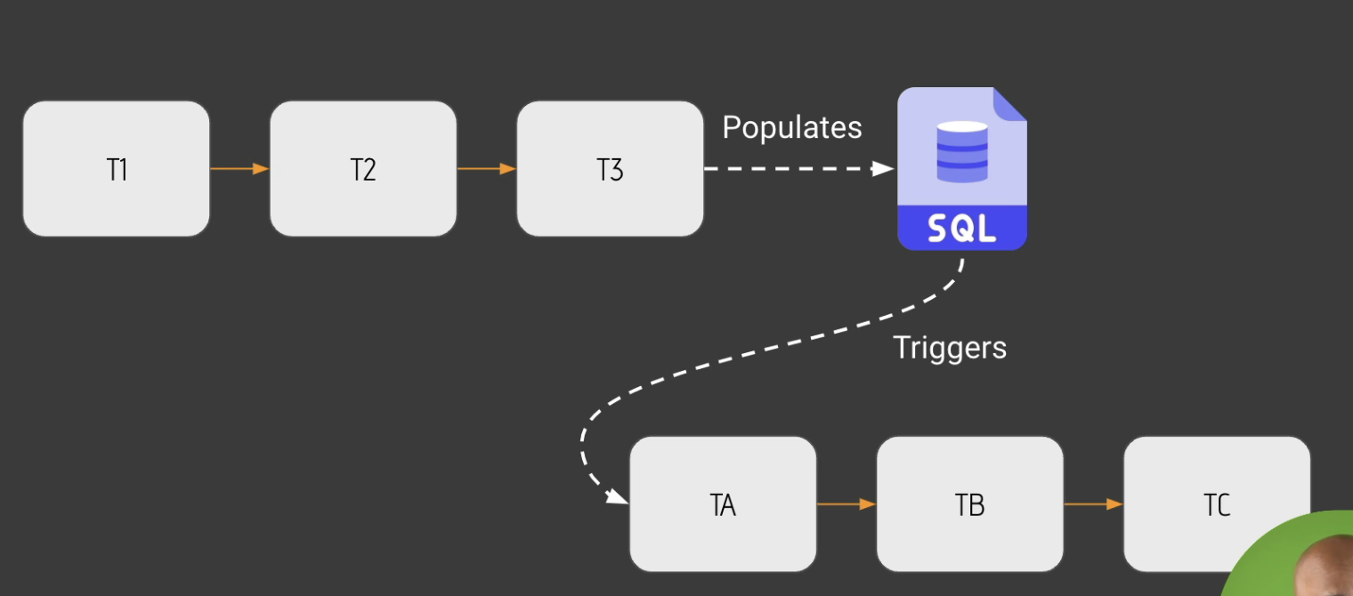

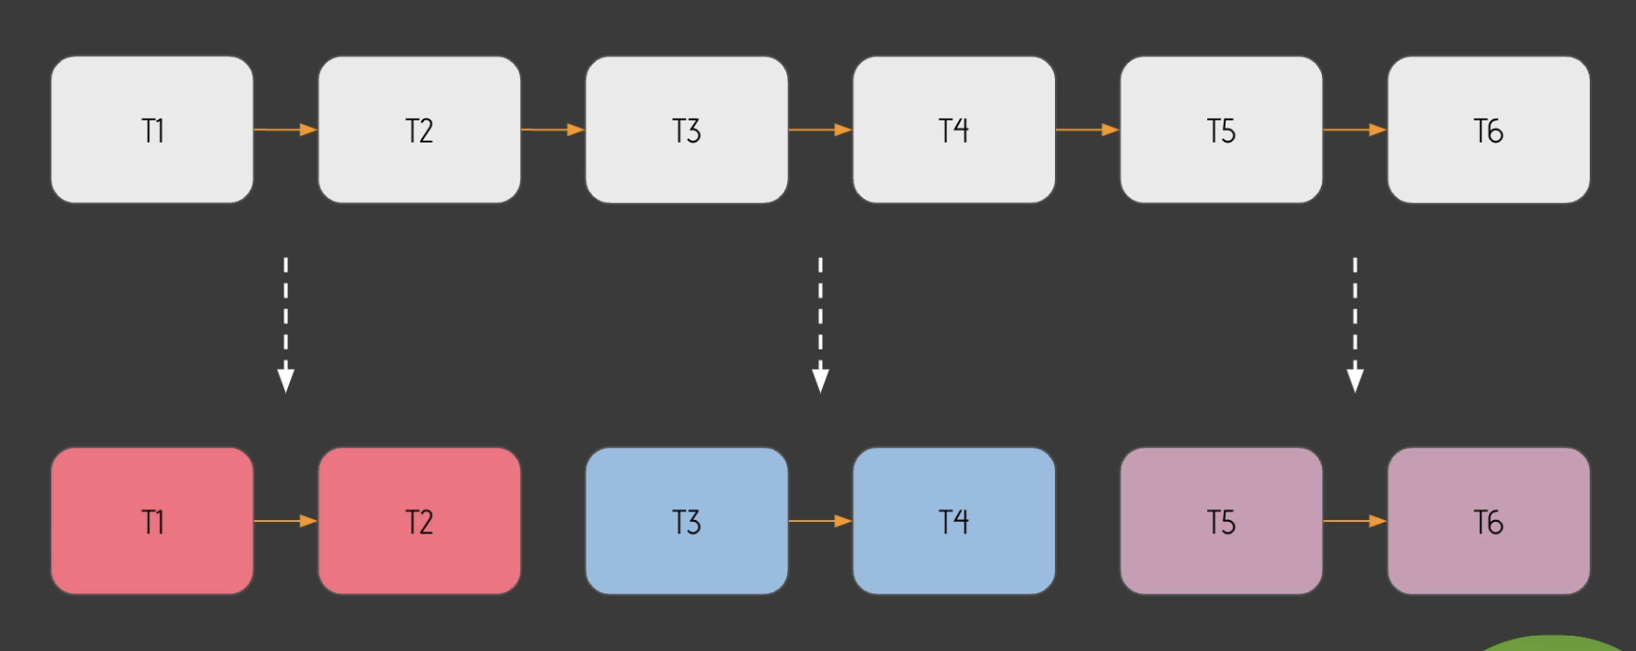

For a very long time. You had only one way of scaling your dags in airflow, which was to define a time interval to your dogs. For example, every day at midnight, once in a week and so on. But this comes to an end because now there is a new feature, a new way of scheduling your dogs. But before showing you what it is, I would like to show you some use cases. And the first one is this one. Let's imagine that you have the data engineer team with the dog 2023 that produces data into a SQL table. Next, you have another team, the data analysts with the data at BTC that needs the data from the SQL table in order to walk. And this is a very common use case that you would like to solve without having to use some complex operators such as the trigger that one operator or the external tasks sensor, the trigger that one operator allows you to trigger knows or DAG from a DAG, whereas the external task sensor allows you to wait for a task in another DAG before moving forward. That being said, those two operators are pretty complex to use. And with that new feature, that new way of scheduling your dogs, it's much easier to wait for data to exist in order to trigger another DAG But let me show you another use case. Let's say you have two dogs, 20 to 33 and to Tbtc. A very common use case is to have one file that you update with t three from the first DAG, and that update triggers the DAG to tbtc. So when you make an update to a data set to some data from a DAG that triggers another DAG. Again, with this new way of scheduling your dogs, you can do that. You can trigger your dogs based on data updates. Now let me show you the last use case, which is very useful if you have different teams working on the same DAG Let's say you have this giant dag with many tasks and different teams working on it, one team on T one and T two, another team on T three and t four and the last one on t5t6. The thing is, you can end up with development frictions. Indeed. Maybe the last team wants to push the DAG in the staging environment in order to test it, whereas another team is not ready for that. Maybe one team feels better to use SQL instead of python operators and so on. So you can have many different things that can create development frictions as everybody is working on the same DAG into the same big file. And this is where instead of having that, you can create micro pipelines. Basically you divide that big data pipeline into many smaller data pipelines where each one is dedicated to a given team with a given file and those micro pipelines, they are dependent to each other. Thanks to the new feature, to the new way of scheduling your tags. So now you have the use cases in mind. It's time to discover what is this new feature.

Dataset:

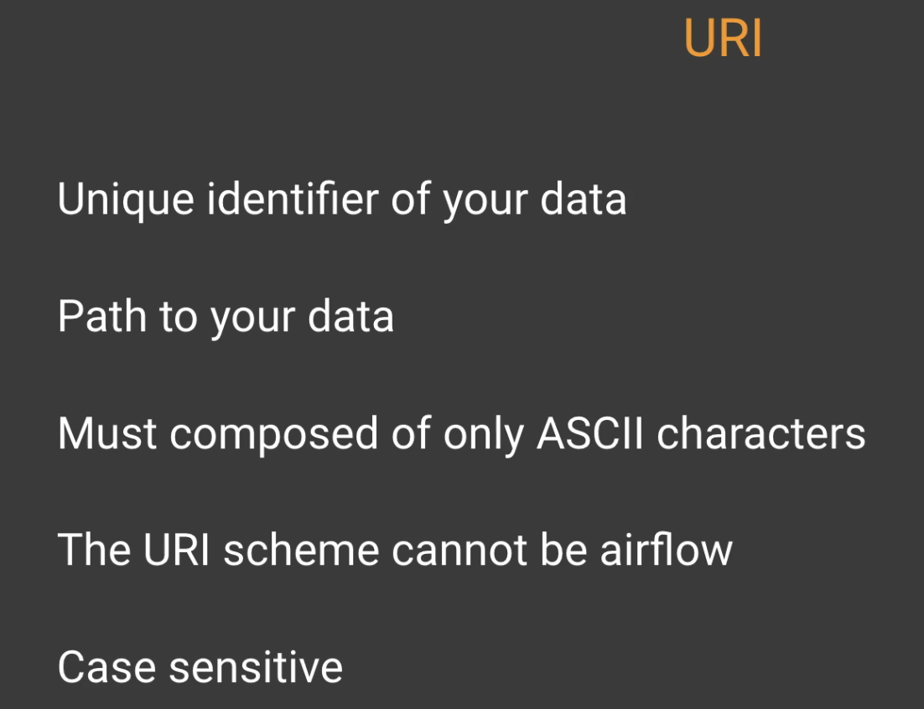

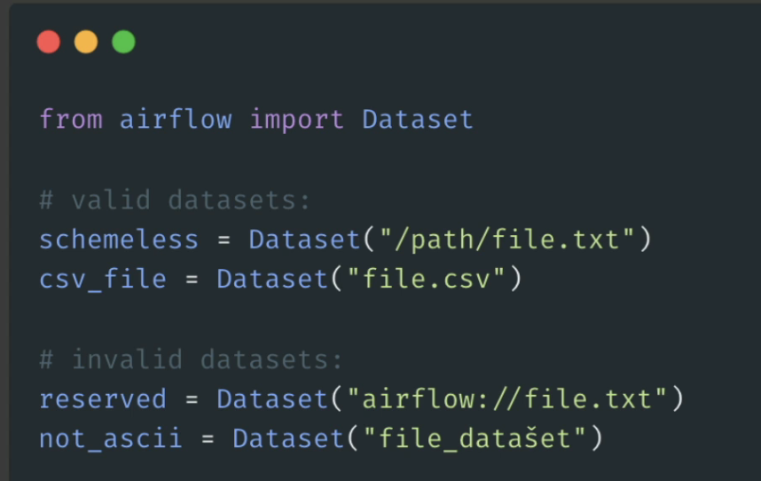

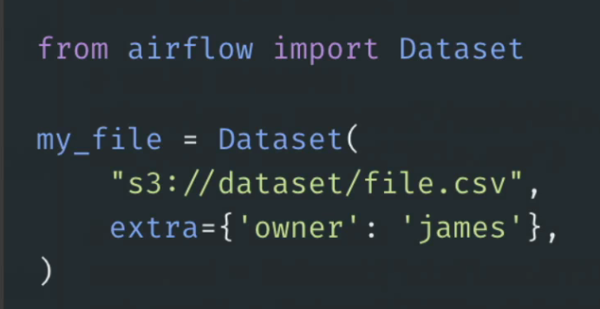

What is a data set? Well, think of a data set as a logical grouping of data, like a file, like a square table. Anything that has data, basically, because actually airflow doesn't really care if it is a file or if it is a square table. You will see that later. But now a data set has two properties and the first one is the URI diary is like the path to the data and the extra parameter is a decent dictionary that you can define. To attach additional information to your data set. You are going to see that in a minute. But now what is exactly the URI? Well, the right to a data set is truly the unique identifier of your data set. You can create as many datasets as you want, and the way to identify a data set is by using the URI. That's how Airflow knows that this data set is different than another one. In addition, the URI is truly the path to your data. So if it is a file in a S3 bucket, you will put a three column slash slash the folder and then your file. If it is a local file, then you will put, I don't know, like slash user slash airflow slash something. Truly, the URI is the path to your data. In addition, you need to make sure that this URI is composed of only ASCII characters. Otherwise it's not going to work. You will receive an error and the URI scheme cannot be airflow. What does it mean? Again, if you use an S3 file, you will put a three column slash slash. Well, you cannot use airflow column, slash, slash. Finally, Uri is K sensitive, so be careful with the uppercase and lowercase characters. Let me show you an example. So you have two data sets that are valid and two invalid data sets. First thing first, if you want to use data sets, you need to make the following import from airflow import data set and just below. To define a dataset, you create a variable. With a data set, you specify the array and you are done. So as you can see, with the two valid data sets, you put the path for the URI. Same thing with the CSV file and just below you have the invalid data sets for the first one. That's because the airflow scheme is used and just below you have the SE with a non ASCII character. So that's why you need to be careful with the AC characters. Otherwise, again, it's not going to work. Now what about the extra parameter? What if I want to attach the owner of a data set? You can do that with the extra parameters. As you can see, with the extra parameter, you define a decent dictionary. In that case, the key is owner with the value gems. So I'm telling that this dataset belongs to GEMS, but again, you can put whatever you want in this extra parameter. Just bear in mind that this parameter is not included, so you should not put any control in that parameter. That's it. Now you know what is a dataset. Again, the dataset is just a group of data. Think of it as a file, as a SQL table, as anything that has data, and you must define a URI.

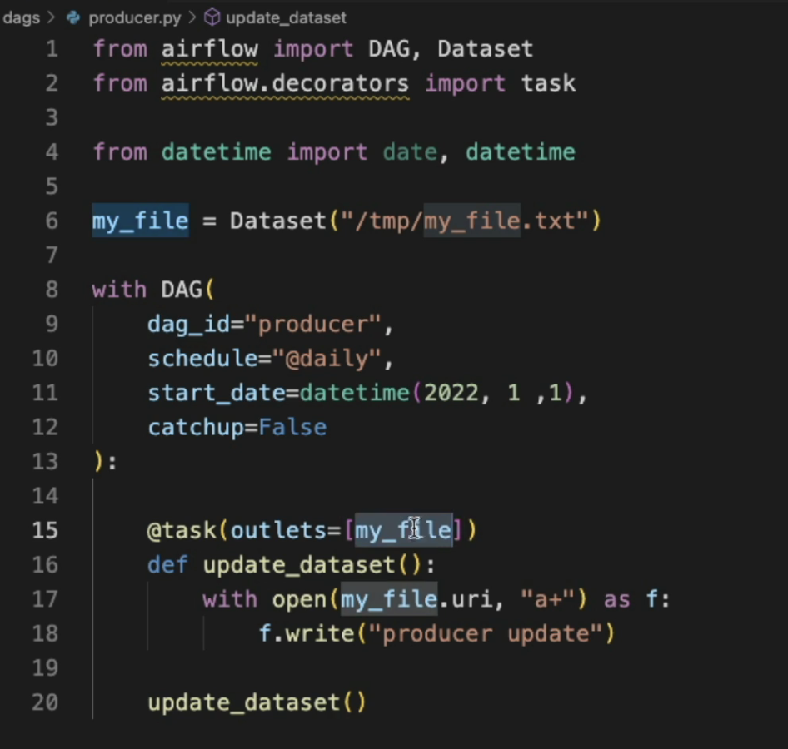

Now there is one last step, which is to indicate to flow that this task update dataset updates the dataset. That is add outlets

Well, you have a new parameter which is outlets. Equals to a list and your dataset. And that's it. By doing that, you indicate to airflow that these task updates the data set might file. So to sum up, in order to create a DAG that interacts with a data set, first you need to import that dataset. Then you need to define the dataset with the URI. And finally, you need to indicate what task updates that dataset with the parameter outlets. So what does it mean? It means that as soon as this task succeeds, well, the DAG that depends on this dataset, my file will be automatically triggered. So let's create the consumer. Dag.

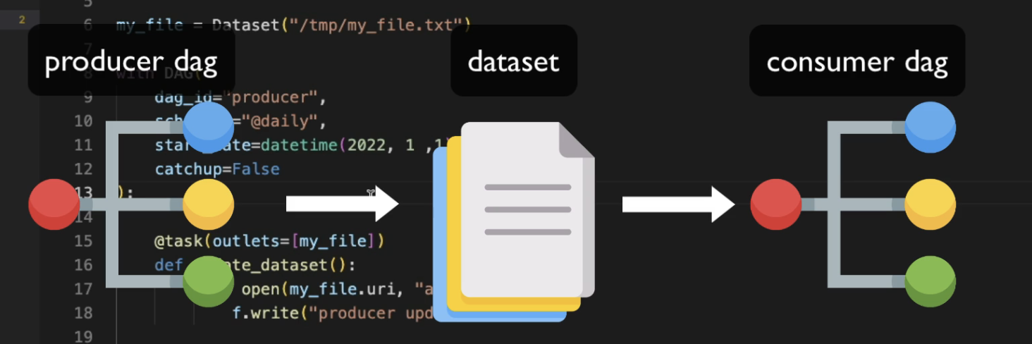

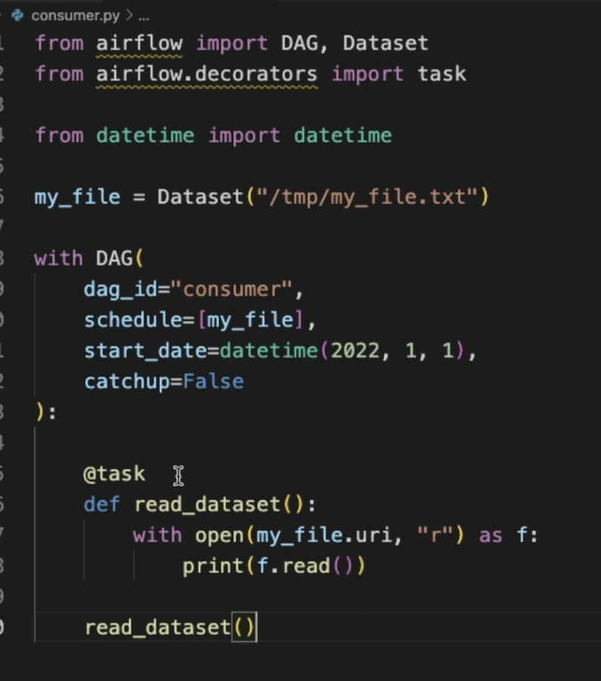

There is no outlets for that parameter because that task doesn't update the dataset. It just reads the data set so you don't have to indicate workflow anything here. So keep in mind, if you want to trigger a DAG based on data updates, you first need to import the dataset object. Then you need to use the same data set as defined in the DAG that updates your dataset. And finally, you need to use that data set as the scheduled value of your DAG.

Schedule Interval Deprecation:

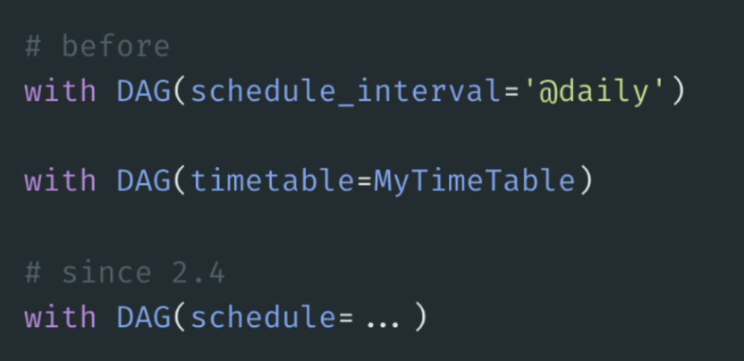

Quick video to show you a major update since airflow to the fore. And as you are going to see, there is no more scheduled interval or actually there is still a scheduled interval, but it's getting deprecated. Let me show you that. So before I flew to that for you had to define the scheduled interval. Remember that the scheduled interval defines the frequency at which to trigger your DAG. For example, you can use a current expression, you can use a time delta object. Also, you have no way to schedule your DAG is by using a timetable. If you don't know what is a timetable, think of it as a more granular way of defining your time interval for your data pipelines. That being said, you had those two parameters scale, interval and timetable. Now they are all gone. You have only one parameter which is schedule. So again, since airflow does four, you can use schedule and as you are going to see now with schedule, you can put either a timetable, a current expiration, a time delta object or a data set. And that's what we are going to see in the next video.

Wait for Multiple Datasets:

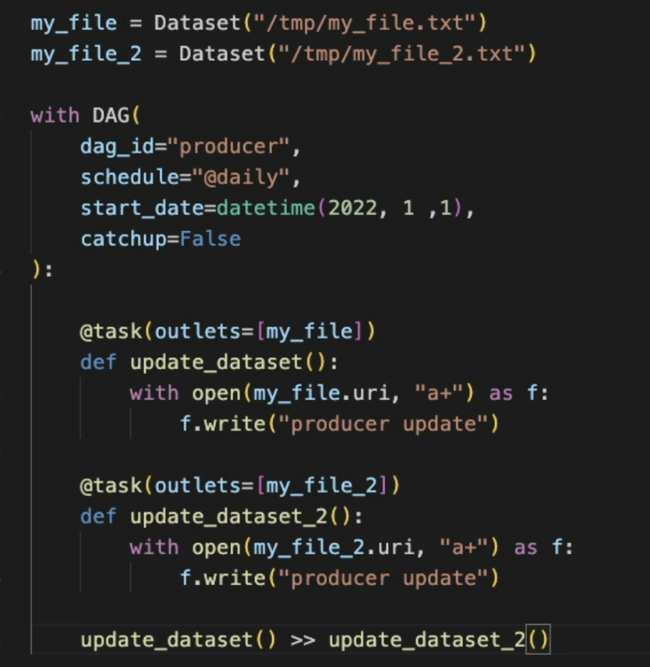

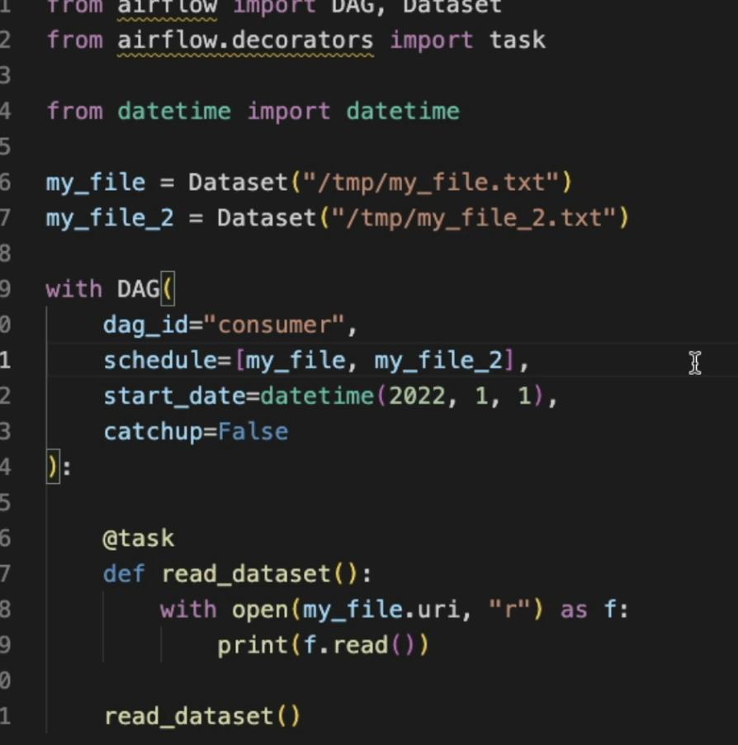

Dataset Limitation:

Datasets are amazing, but they have limitations as well:

* DAGs can only use Datasets in the same Airflow instance. A DAG cannot wait for a Dataset defined in another Airflow instance.
* Consumer DAGs are triggered every time a task that updates datasets completes successfully. **Airflow doesn't check whether the data has been effectively updated.**
* You can't combine different schedules like datasets with cron expressions.
* If two tasks update the same dataset, as soon as one is done, that triggers the Consumer DAG immediately without waiting for the second task to complete.
* Airflow monitors datasets only within the context of DAGs and Tasks. If an external tool updates the actual data represented by a Dataset, Airflow has no way of knowing that.

Executor:

The executor is one of the most important pieces of airflow. And the first thing that you need to know about it is that it doesn't run your tasks, it doesn't execute your tasks. Even if it is called executor, it doesn't execute your tasks. Instead, it defines how to run your tasks on which system. And basically you have many different executors that you can use. They are local executors and remote executors. For example, you have the local executor to run multiple tasks on a single machine. You have the sequential executor to run one task at a time on a single machine. And you have the remote executors like the self executor to execute your tasks on the salary cluster on multiple machines. And you have the communities executor to run your tasks on a Kubernetes cluster, same thing on multiple machines in multiple pods. So as you can see, there are many different executables that you can use according to your use case and your workload to configure your executor. The only thing that you need to change is the executor parameter in the configuration file of F2. There are other parameters that you may need to change according to the executor you use. For example, with the seller executor you have a couple of other parameters that you can define something with the is executor, but not really. You are going to see all of them just after that video.

Remove DAG examples

To keep our Airflow instance nice and clean, we are going to remove the DAG examples from the UI

To do this

1. Open the file docker-compose.yaml
2. Replace the value 'true' by 'false' for the AIRFLOW__CORE__LOAD_EXAMPLES environment variables

Queue:

What is a Q? How does it work and why it is so useful for you? Let me show you this first. What is the queue? Well, you can think of a queue as a line of people waiting for something, but in the context of airflow, it's a line of tasks waiting to be triggered. So you have your queue shown in green and tasks are pushed into that queue in order to be executed. So for example, one task is pushed into it t one, then another task is pushed into it. T two And it goes like that basically queues work first in, first out. So t one is executed first, then t two, then t three and so on. Now what about the queues in the context of airflow? Well, the good thing with the queues is that we sell where you have multiple workers, multiple machines, and maybe one machine has a lot of CPUs, maybe another machine has a GPU and maybe another one has less resources where with the queues you can define on which machine, on which worker you want to execute tasks according to their specificities. For example, you have a task that needs a lot of resources to be executed. You can put it into the queue, high CPU and then the worker with a lot of CPUs five in this example will take out that task from that queue in order to execute it. Something if you need to run a machine learning model, you can send the task into the queue ML underscore model which is connected to the worker with a GPU. And so this is where the task will be executed. Last but not least, you can have a default queue where all other tasks will be executed in the worker with less resources. So you see with queues you are able to distribute your tasks among multiple machines according to the specificities of your tasks and your machines.

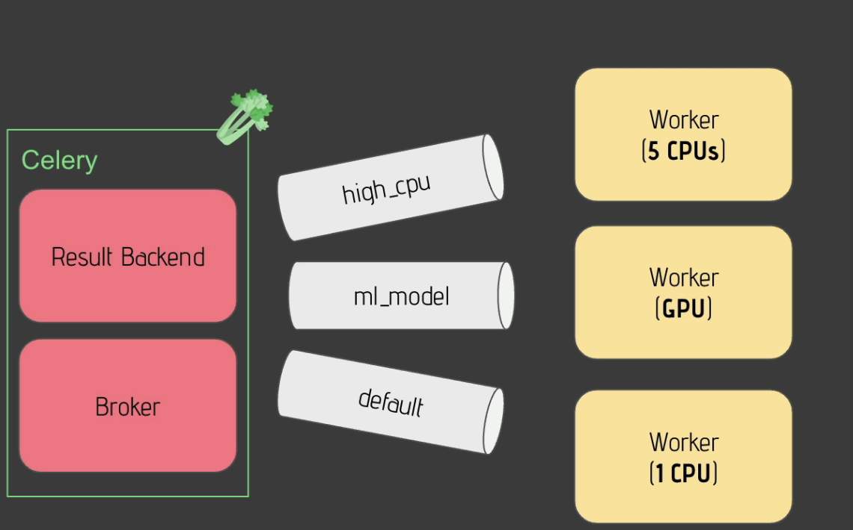

Send Task to specific Queue:

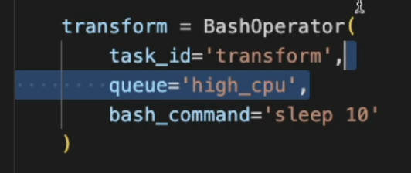

Repetitive Patterns:

Your disappearance can become pretty complex indeed. Let's imagine that you have the following one with three tasks in charge of downloading files. One task to check those files and other tasks in charge of processing those files. As you can see, those tasks are doing the same logical thing. They don't load files and the three other tasks are doing the same logical thing, the process files. So what you would like to do instead is to have one task that groups all the downloading tasks and one other task that groups all the tasks that process the files. Why do you want that? To make your dag easier to read and to maintain. So how to implement that by using subtasks?

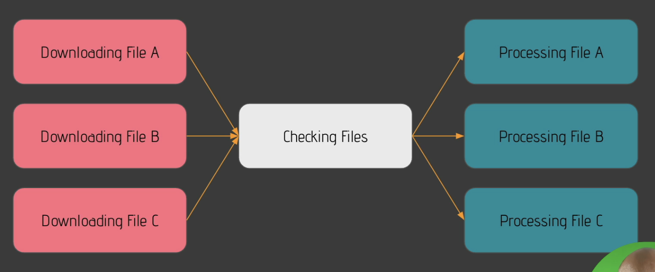

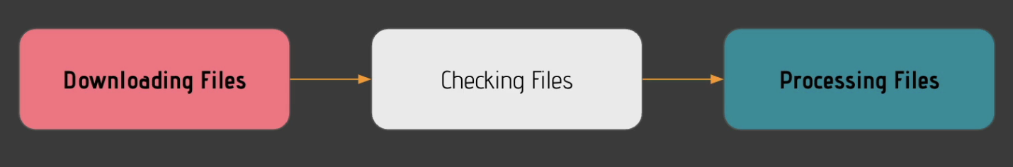

**Add the DAG group_dag.py**

Add the DAG group_dag.py into the DAGs folder.

1. From Visual Studio Code, right-click on the folder dags and click on "New File"
2. Give the name group_dag.py
3. Copy and paste the following code into it

from airflow import DAG  
from airflow.operators.bash import BashOperator  
  
from datetime import datetime  
  
with DAG('group_dag'**,** start_date=datetime(**2022, 1, 1**)**,** schedule_interval='@daily'**,** catchup=False) as dag:  
 download_a = BashOperator(  
 task_id='download_a'**,** bash_command='sleep 10'  
 )  
  
 download_b = BashOperator(  
 task_id='download_b'**,** bash_command='sleep 10'  
 )  
  
 download_c = BashOperator(  
 task_id='download_c'**,** bash_command='sleep 10'  
 )  
  
 check_files = BashOperator(  
 task_id='check_files'**,** bash_command='sleep 10'  
 )  
  
 transform_a = BashOperator(  
 task_id='transform_a'**,** bash_command='sleep 10'  
 )  
  
 transform_b = BashOperator(  
 task_id='transform_b'**,** bash_command='sleep 10'  
 )  
  
 transform_c = BashOperator(  
 task_id='transform_c'**,** bash_command='sleep 10'  
 )  
  
 [download_a**,** download_b**,** download_c] >> check_files >> [transform_a**,** transform_b**,** transform_c]

SubDags:

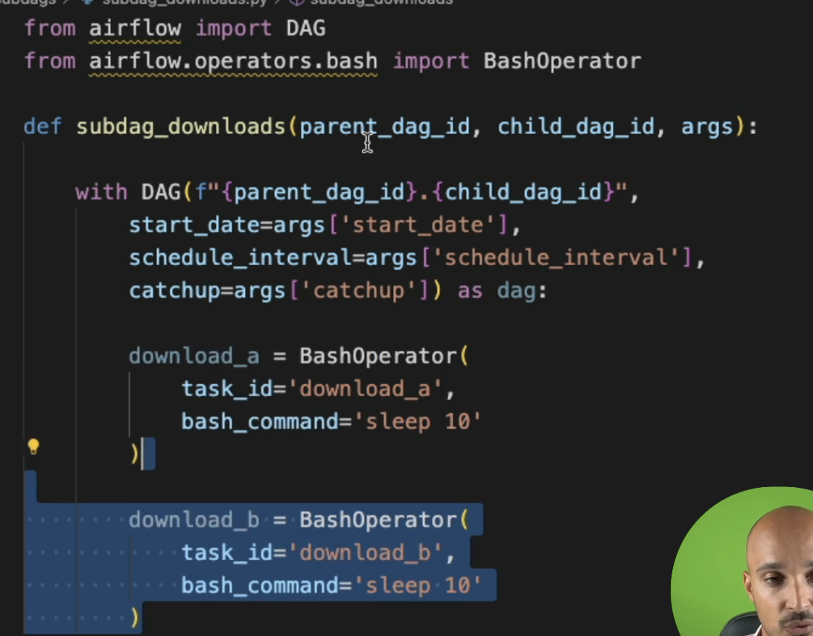

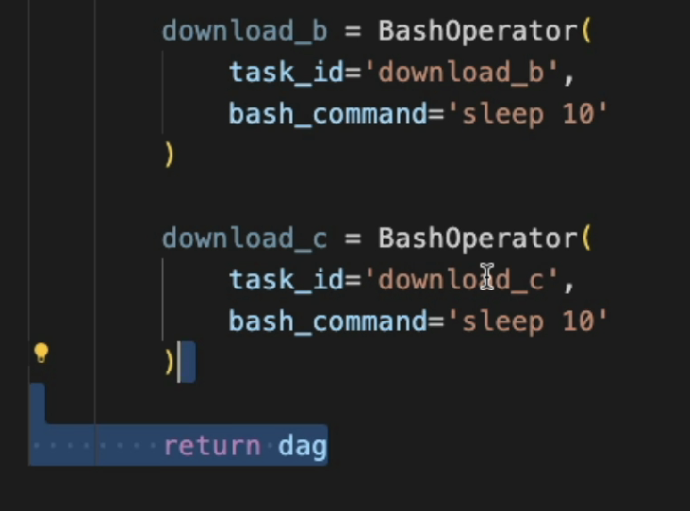

In parent

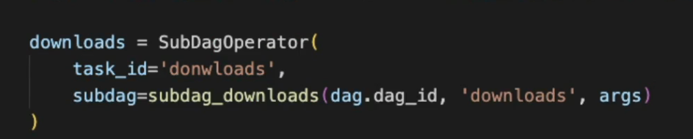



**SUBDAGS ARE DEPRECETAED AND NO LONGER IN USE INSTEAD USE TASK GROUP**

Task Group:

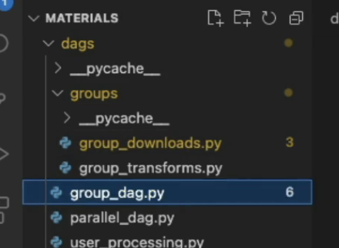

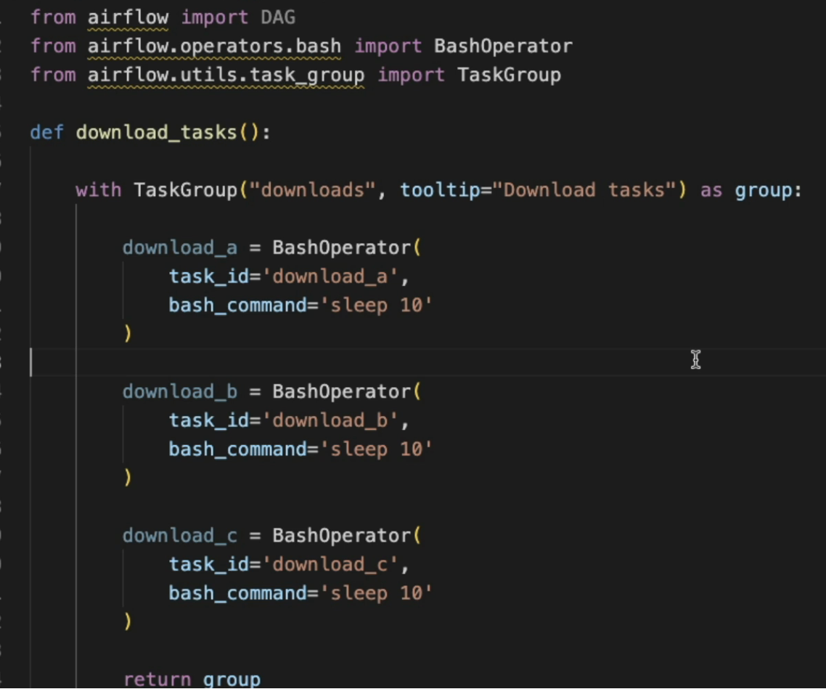

Parent:

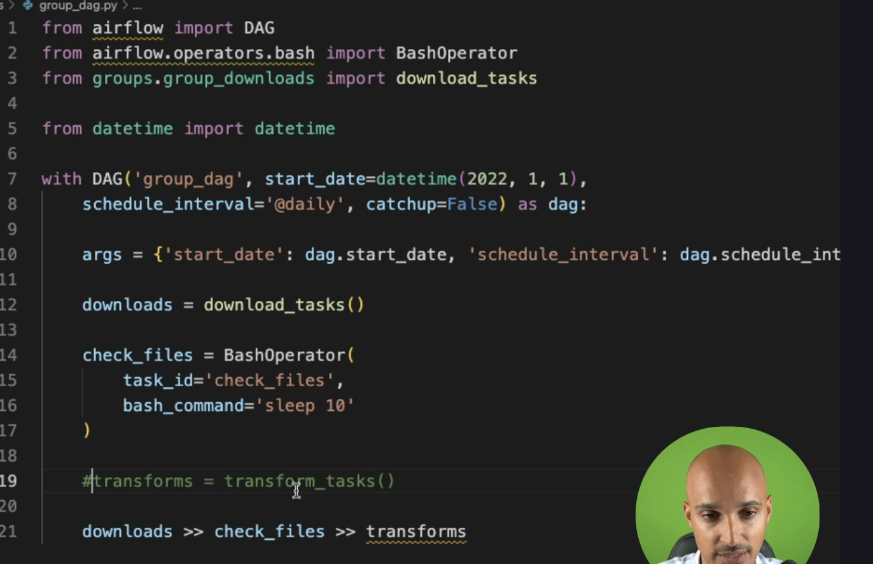

**Add the DAG xcom_dag.py**

Add the DAG xcom_dag.py into the DAGs folder.

1. From Visual Studio Code, right-click on the folder dags and click on "New File"
2. Give the name xcom_dag.py
3. Copy and paste the following code into it

from airflow import DAG  
from airflow.operators.python import PythonOperator  
from airflow.operators.bash import BashOperator  
  
from datetime import datetime  
  
  
def _t1():  
 None  
  
  
def _t2():  
 None  
  
  
with DAG("xcom_dag"**,** start_date=datetime(**2022, 1, 1**)**,** schedule_interval='@daily'**,** catchup=False) as dag:  
 t1 = PythonOperator(  
 task_id='t1'**,** python_callable=_t1  
 )  
  
 t2 = PythonOperator(  
 task_id='t2'**,** python_callable=_t2  
 )  
  
 t3 = BashOperator(  
 task_id='t3'**,** bash_command="echo ''"  
 )  
  
 t1 >> t2 >> t3

XCOM:

How to share data between your tasks. Let's say that you have two tasks listing file names and downloading files, and your goal is to fetch the file names from listing file names into the task, downloading files. How to do that? Well, the first way is by using an external tool like a database or shared file system. For example, listing file names pushes the data into the external tool and finally downloading files pulls the data from the external tool. This is something that you can do, and this is very useful if you have a lot of data, if you want to share gigabytes or terabytes of data. But now the second way to do it and the native way to do it is by using x comes. So listing file names pushes x com that contains the list of fine names and downloading files pools that x come from the database of air flow to get the file names. That's how it works. The X Come contains the information you want to share between your tasks and it is stored into the meta database of airflow. So that being said, what is the X come? It stands for cross communication and it's nothing more than a little package that allows you to exchange small amount of data. You should not share terabytes or gigabytes of data. With X comes Y because they are limited in size. For example, if you use SQLite you can start up to two gigabytes of data for a given XCOM. If you use Postgres, you can start up to one gigabyte of data in a given XCOM, but if you use my SQL, you can start up to 64 kilobytes of data for given XCOM. So be careful x comes that allows you to share data between your tasks, but you should share metadata between your tasks and not the data itself.

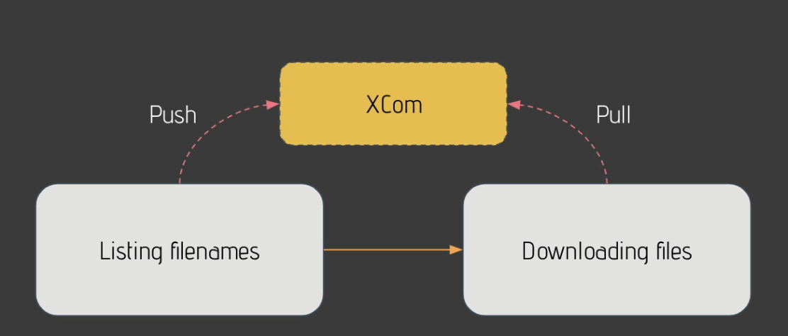

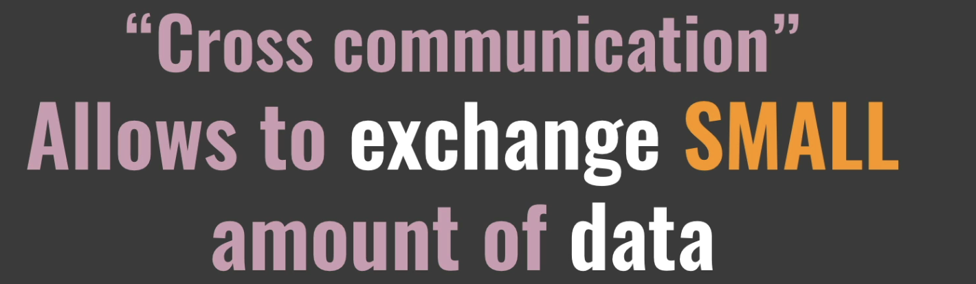

First you need to use the parameter T and t is the task instance object of your task allowing you to access the method x come underscore push. So remember that when the operator runs, that creates a task instance.

from airflow import DAG  
from airflow.operators.bash import BashOperator  
from airflow.operators.python import PythonOperator  
from airflow.operators.subdag import SubDagOperator  
from airflow.utils.task_group import TaskGroup  
  
from random import uniform  
from datetime import datetime  
  
default_args = {  
 'start_date': datetime(**2020, 1, 1**)  
}  
  
def _training_model():  
 accuracy = uniform(**0.1, 10.0**)  
 print(f'model\'s accuracy: {accuracy}')  
  
def _choose_best_model():  
 print('choose best model')  
  
with DAG('xcom_dag'**,** schedule_interval='@daily'**,** default_args=default_args**,** catchup=False) as dag:  
  
 downloading_data = BashOperator(  
 task_id='downloading_data'**,** bash_command='sleep 3'  
 )  
  
 with TaskGroup('processing_tasks') as processing_tasks:  
 training_model_a = PythonOperator(  
 task_id='training_model_a'**,** python_callable=_training_model  
 )  
  
 training_model_b = PythonOperator(  
 task_id='training_model_b'**,** python_callable=_training_model  
 )  
  
 training_model_c = PythonOperator(  
 task_id='training_model_c'**,** python_callable=_training_model  
 )  
  
 choose_model = PythonOperator(  
 task_id='task_4'**,** python_callable=_choose_best_model  
 )  
  
 downloading_data >> processing_tasks >> choose_model

Branch Task:

A very common use case in airflow is to choose one task or another according to a condition. And for that you have the branch operators. So let's imagine that you have the following data pipeline with a branch task. In this task, you have a condition and based on the output of that condition, you return a task ID or an order that corresponds to the next task to execute. So for example, you may have a condition that returns true, and if it is the case, then you want to execute task A So the branch task returns the task, the task. A And if that condition returns false, then you want to execute task C So the branch task returns the task ID, Task C That's how it works and that's how you can choose one task or another. Remember, you have a branch operator. The branch operator has a condition based on the output of that condition. You return one task ID or another. Let's see how it works.

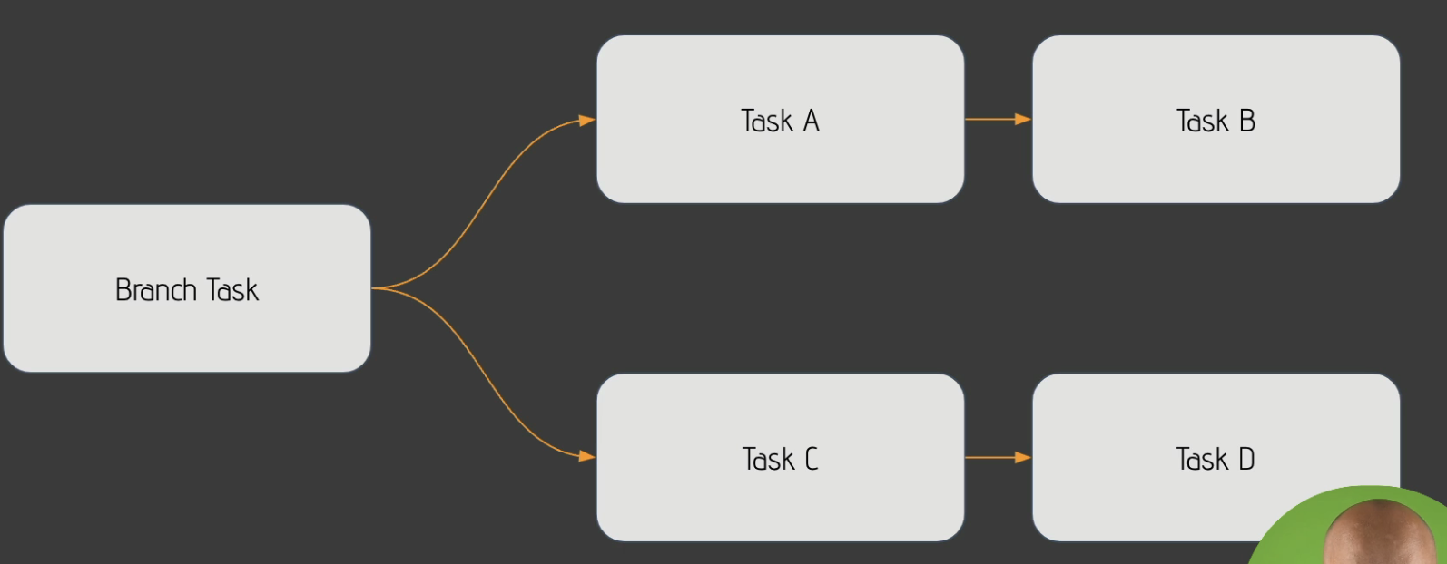

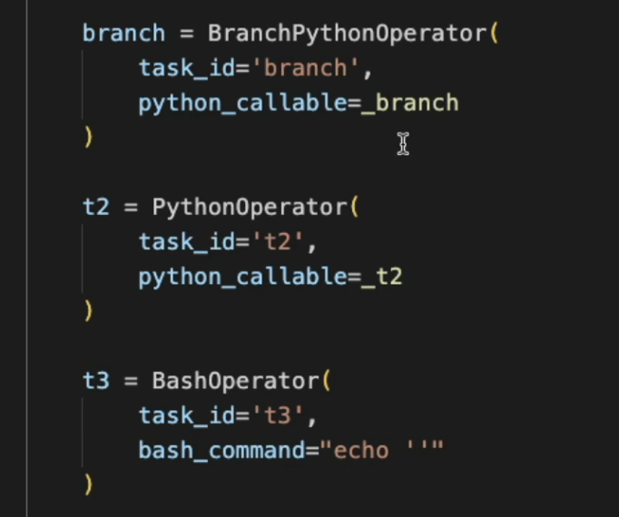

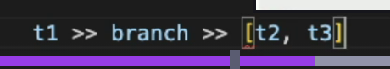

Trigger Rules:

